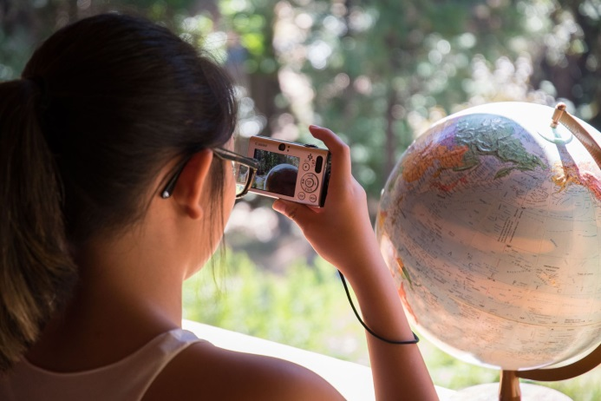
Wading through a Labyrinth of Water Issues
The Climate Change Agents began their summer with a chance to appreciate the properties of water and honor the life it brings to all species—and then to realize that if we honor life we must apply our hearts and minds to safeguarding our human family from the disparaging effects of climate change and its limitations as well as its devastations in terms of water. Inspiration, preparation, collaboration, prevention and creative thinking all played a role in addressing both the social climate and the actual abatement of further damage through shifts in our approach to addressing climate change. Around the world and here at home, the erratic effects of climate change manifest themselves in the water we do or do not have.
A quick word splash helped students identify water-based terms such as drought, flood, hurricane, cyclone, albedo effect, rising tides, acidification and melting glaciers and polar ice caps. They also identified positive terms such as hydropower, tidal energy, water catchment and a series of water-borne disease prevention plans.
The following pages detail in photos the nature of their weeklong experience of what it means to be a change agent, honoring the league of species.
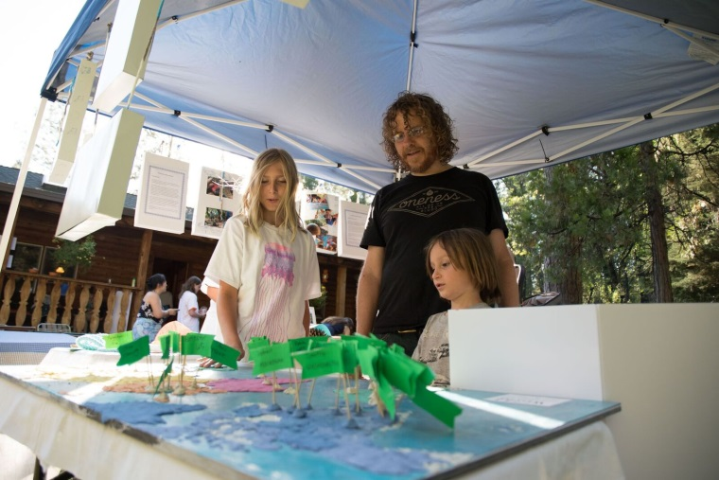
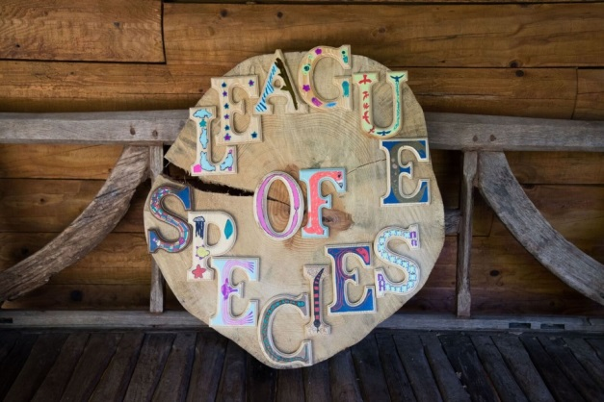In summer of 2017, the Climate Change Agents considered the impact of climate change on the water cycle and the resulting erratic weather patterns that affect human and wildlife species. They conducted experiments, designed new technologies, and set out to inspire positive action through poetry, dance and music. They wrote speeches and learned photography skills to enhance their ability to inspire others. They simultaneously honored and learned from local professionals and volunteers who had responded to local and climate challenges with accountability and integrity. They also highlighted communities around the world already pursuing 100% renewable energy plans, and they contributed to the plan to pass such a resolution in Nevada City.
Wisdom Exchanges Extend Connection to Human Family
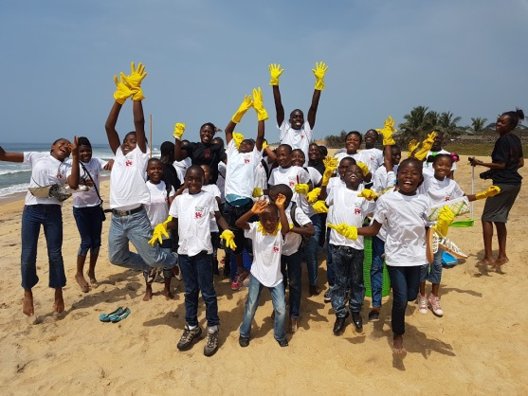
The Change Agents honored global wisdom exchange partner schools for their responses to water-related climate change issues. In Liberia, Full-Circle Learning students from multiple schools had come together earlier in the year to generate awareness of acidification and ocean degradation.
In Zambia, multiple schools planned a cholera prevention project projects due to the increase in water-borne disease. One school experienced flooding and wanted to prevent new outbreaks. In addition, the floods had left great potholes in the dirt roads, increasing traffic accidents and resulting deaths. Students at the school responded with a project that would build community unity while taking advantage of their gift for music. They went out into the street singing. As they did, they collected rocks. Neighbors came out to hear them sing. As they sang, they poured the rocks into the potholes, and the neighbors began to help. Street by street, eventually they filled all the potholes between the school and the main road, reducing places for mosquito-infested stagnant water to collect and reducing the number of traffic accidents.
Meanwhile, in Zambia’s Blessed Vale School, Elisha, age 12, contributed used his artistic skills to draw a fish, which we added to the poster about water issues. Several classes at the Mildred School, wearing gray and blue, participated. Elisha appears in a red sweater, below.
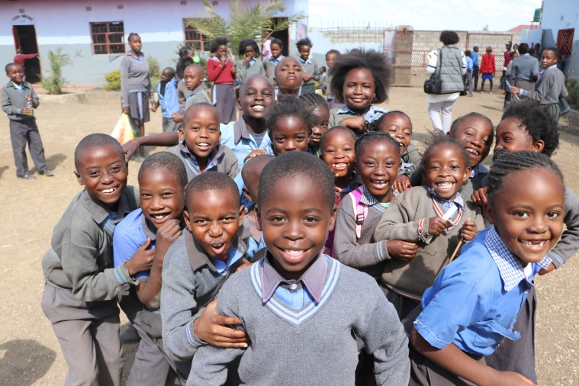
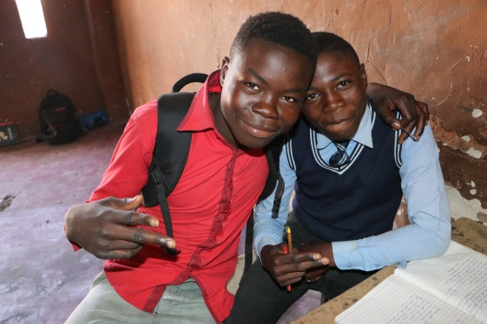

We also had the joy of receiving a wisdom exchange partner onsite this year. Representatives from Vanuatu, a nation of increasing cyclones and nearby shrinking islands, left a profound impression on the change agents with fearful tales of the impact of climate change on Oceania, as well as stories that showed the creativity of their water catchment systems, water conservation methods and the resilience and reverence for nature among their people.
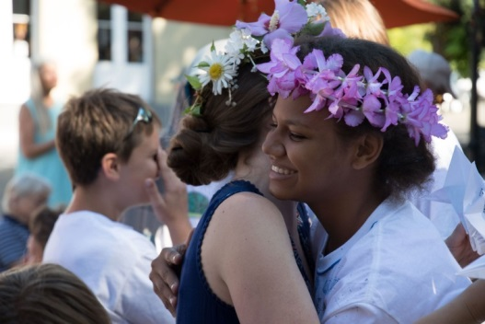
These onsite wisdom exchange partners, Fredlynn and Rossana Kalulu, represented the Climate Change Ministry of Vanuatu, a body that contacted our Nevada County Climate Change Coalition requesting scholarship to send scholarship applicants. Here, Rossana, 14, receives a hug from teacher Katie Smith after her performance.
Adding Content to Context
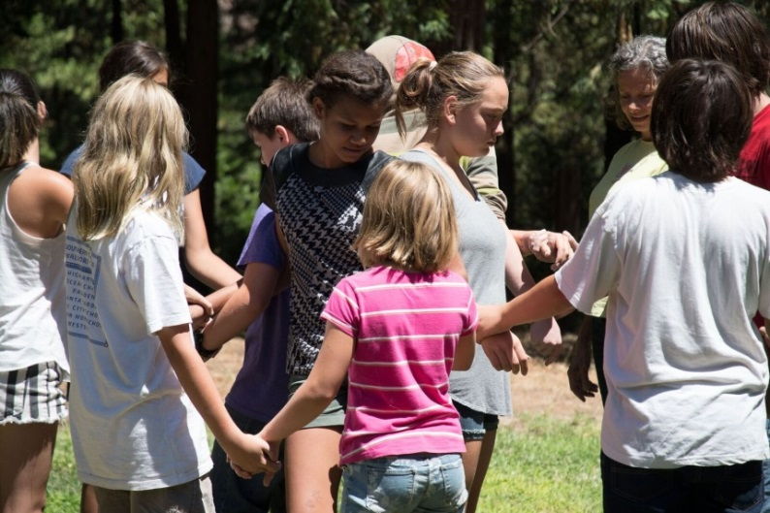
Stories of ingenuity and indigenous wisdom from abroad paralleled their work as the Change Agents began to understand options for action within their own community. They prepared to explain to others the science and the social justice issues related to water and climate change—for example, the . challenge of meeting fresh water needs around the world.
At left, they demonstrated the unity of hydrogen and oxygen swirling down a stream in water molecules that travel from a snowy peak to the rivers that carry water toward the ocean dwellers.
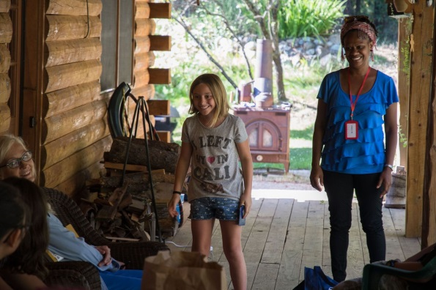
In the adjacent photo, they played charades to see who could guess the fish serving as indicator species in the local lakes. They also assessed the exact daily freshwater needs of primary species in the watershed. They experimented with a Pelton Wheel as an energy source. Later, they went to Scott’s Flat Reservoir.

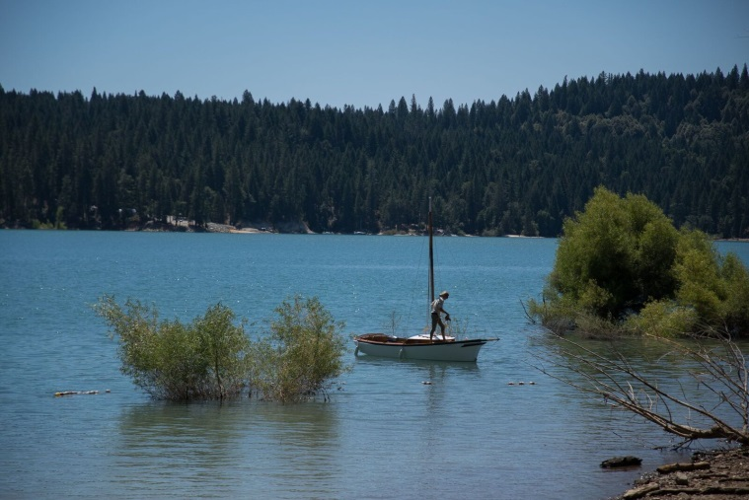
TheyThey sailed out to measure the water temperature, comparing current habitat conditions with those during recent drought years. They learned from sailor Peter Domecq about the quadruple bottom line {based on collaborative village projects that consider the needs of people, the planet, the profit and personal awareness, using participatory democracy). They also heard from engineer George Dean stories demonstrating ways to ensure safety, integrity and accountability on largescale engineering or flood management projects.

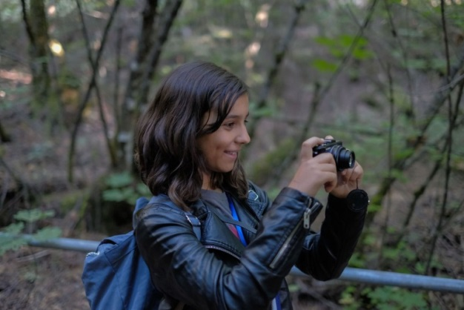
SMalina Mitchell practiced shooting a watershed as one of the first assigned photographers in Daven Mathies’ photography class. She intermittently documented birds and riparian habitat notes along with the others at a Rock Creek cookout. Expert birder Don Rivenes led the way. 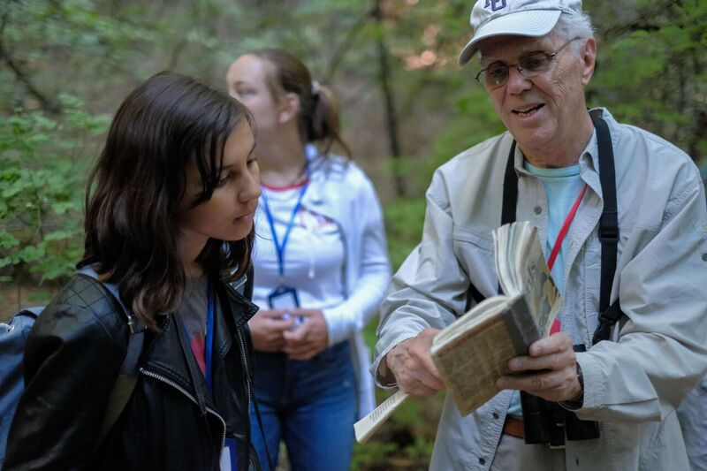
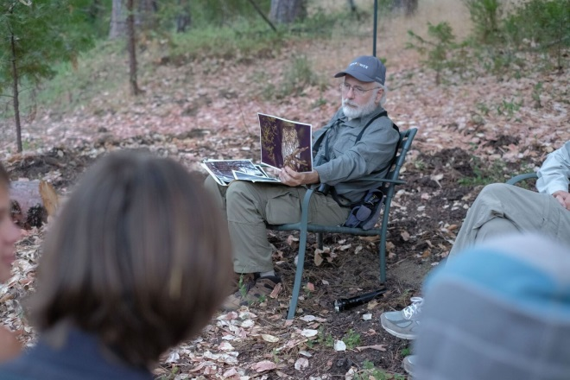
Back at the lodge, Rudy Darling, the owl whisperer, offered a presentation under the madrone tree. He ultimately led the group to the best twilight courting site for owls once again, in the oak trees above the chicken coop.
Understanding the role of collaboration meant working out hypothetical local and global conflicts on the conflict bridge. It also meant looking for models of collaboration such as Peabody Creek, an urban stream subject to flooding in Grass Valley, where professionals and citizens bring many aptitudes to the effort to restore the creek to its original flood plain.

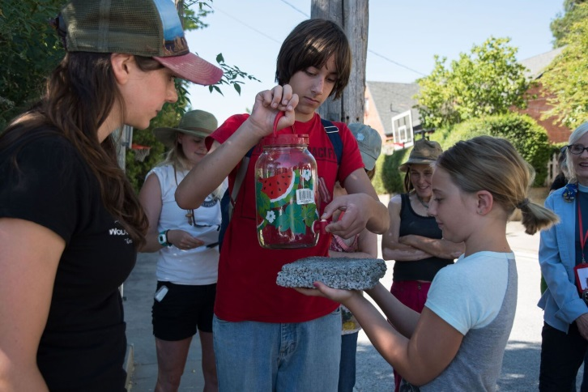
Tusu t Karin Emmanuel, of Sierra Streams, and Maiya Greenwood, of American Rivers, demonstrated innovations such as marketing efforts to help citizens reroute drain spouts onto gardens. They also showed the effectiveness of the new permeable sidewalks on North Church Street.

UnderA
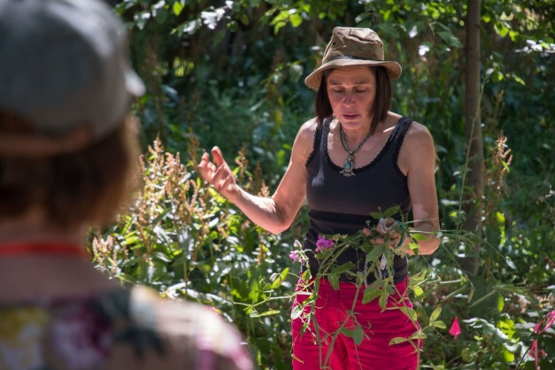
Together, the group spent time removing non-native, invasive species, along with Nina Allen, who also demonstrated water catchment systems and pollinator gardens on one of her properties.

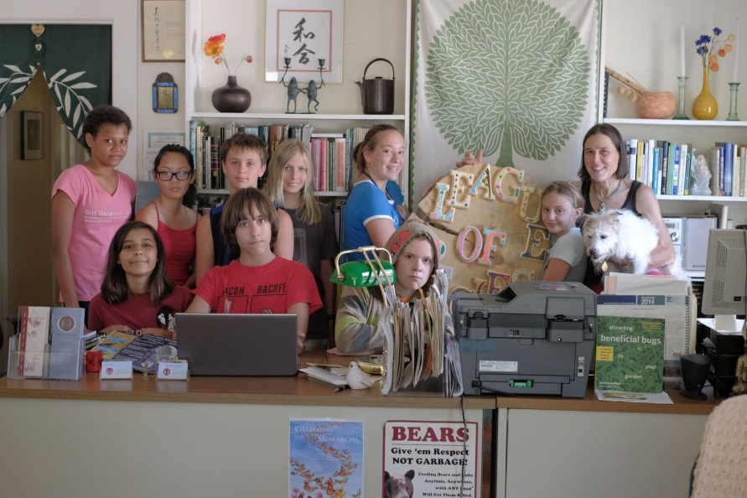
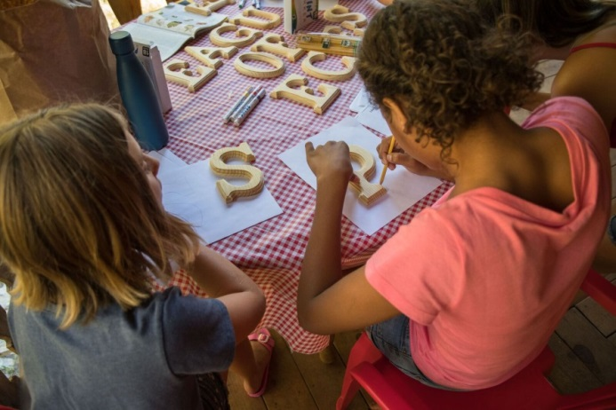
The change agents had prepared a gift related to the camp’s theme to honor Nina, who has worked individually and collaboratively to protect all species, using hydrology, solar, straw bale construction, water catchment, pollinator gardens, composting toilets and is now building a clay earth structure. She dedicates her properties to the education of the community as much as possible.

Nina Allen, as a descendant of President Woodrow Wilson, the US President who formed the League of Nations, would receive the gift at her office from the Change Agents. They felt her evolving environmental centers needed a “League of Species” sign.

Challenging the Community
The Change Agents looked beyond their own community for models of collaboration and excellence they could honor, toward cities around the world that have initiated 100% renewable energy plans.
Artists Rene Sprattling and Susie Steinbarth guided them in modeling a raised-relief map for the exhibit. Nevada County took its place among the striving communities. The Change Agents’ exhibit at the farmer’s market would offer an opportunity for locals to support the effort to replace fossil fuels with renewables. Visitors would also receive tools for taking immediate individual action, such as the use of “renewable energy air conditioners” (accordion fans) that do not expel greenhouse gas.
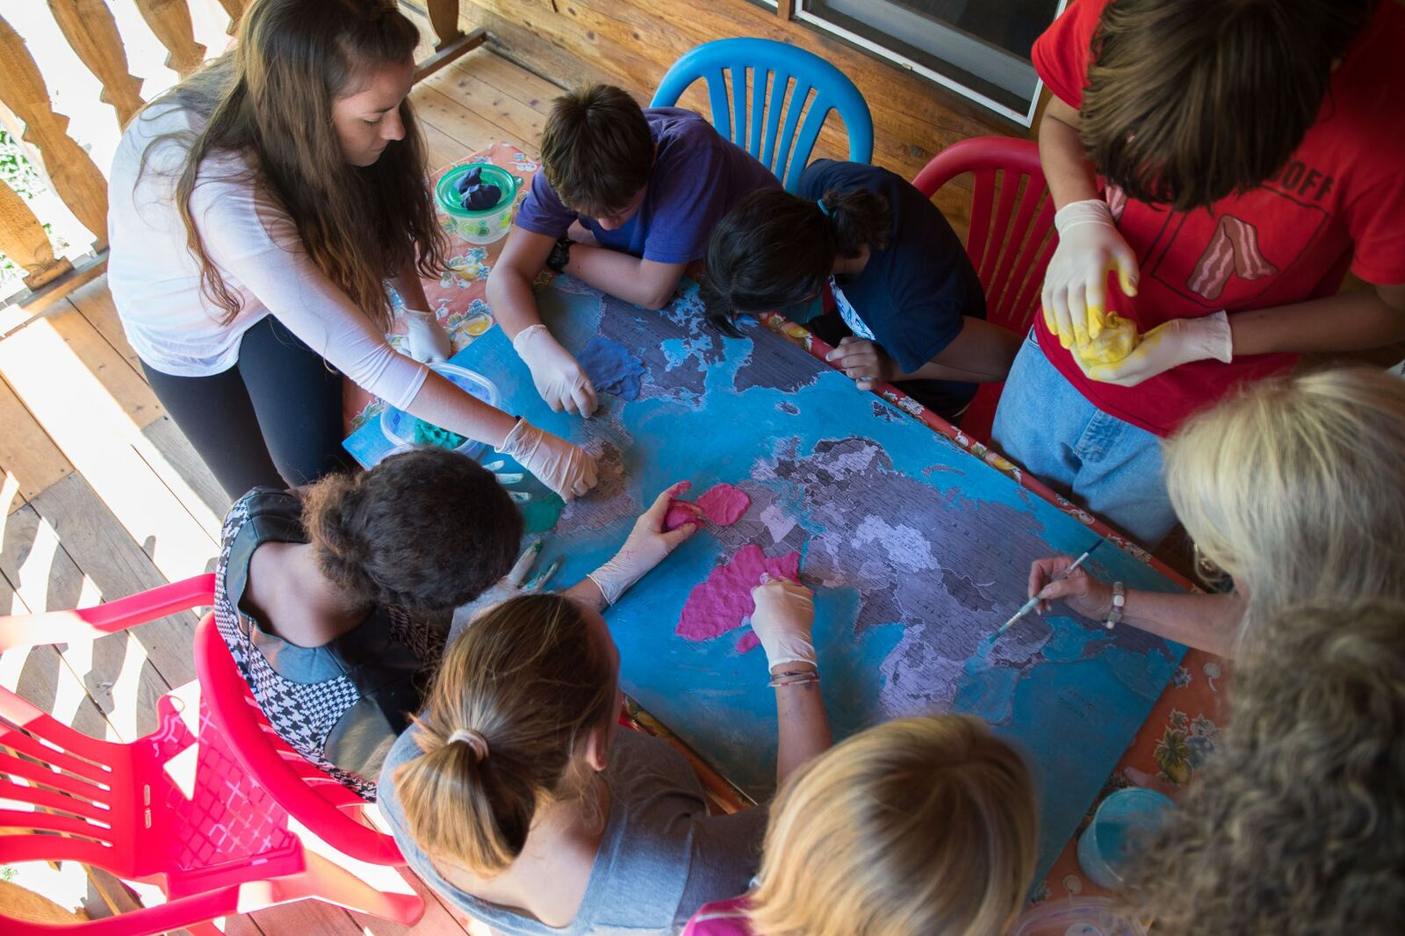

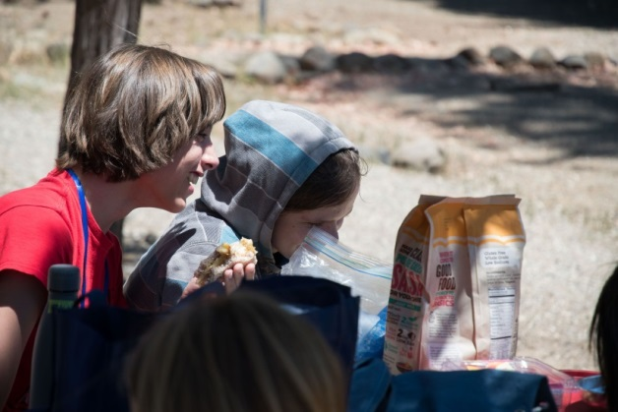
Pooling Talents
The young artists put finishing touches on the 3-D topographical map, placing a green flag on each of the communities with energy plans in place.
Meanwhile, some students worked on their photography exhibits and on speeches. Some of our humble engineers had created innovative designs for improving existing renewable energies and creating new tidal energies that do not harm oceans species—even one that repurposes fossil fuel infrastructure.
Our violinist practiced his original composition to bring the group’s poem Water to life. The Taiko drummers and choreographers worked on the effectiveness of their message calling the human family to honor all species.
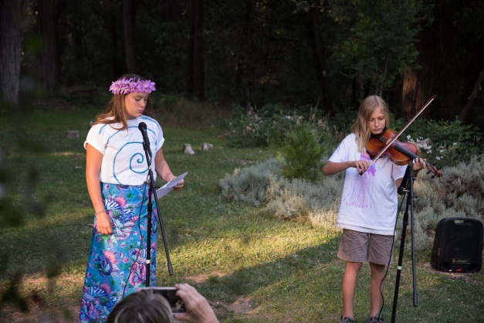
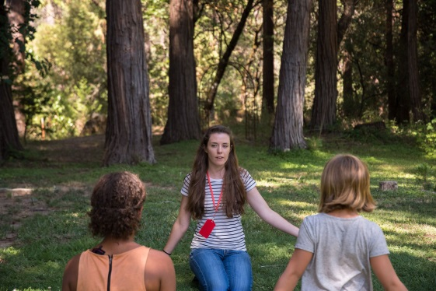
Each Change Agent made valuable contributions to the evening program and to the public exhibit that would occur at the farmer’s market the next day, to inspire others to protect all living things from the effects of climate change.

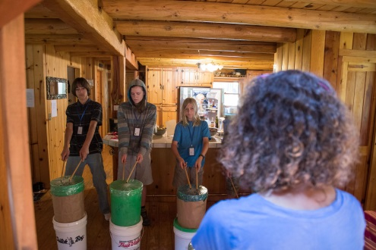

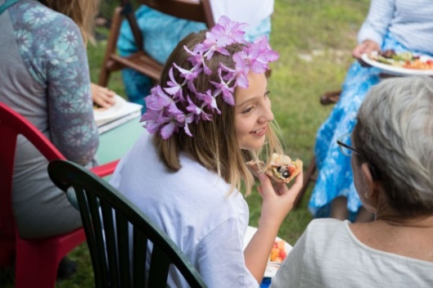
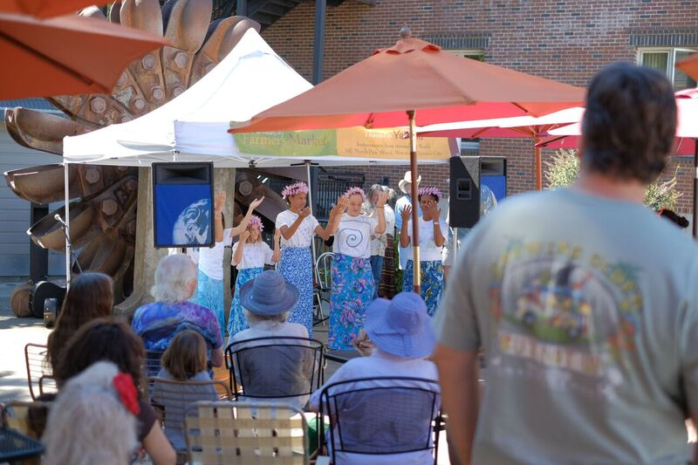
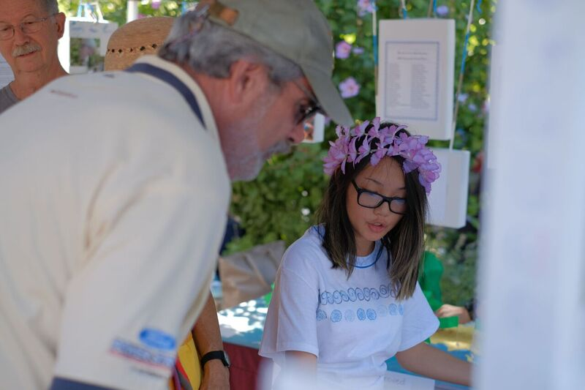

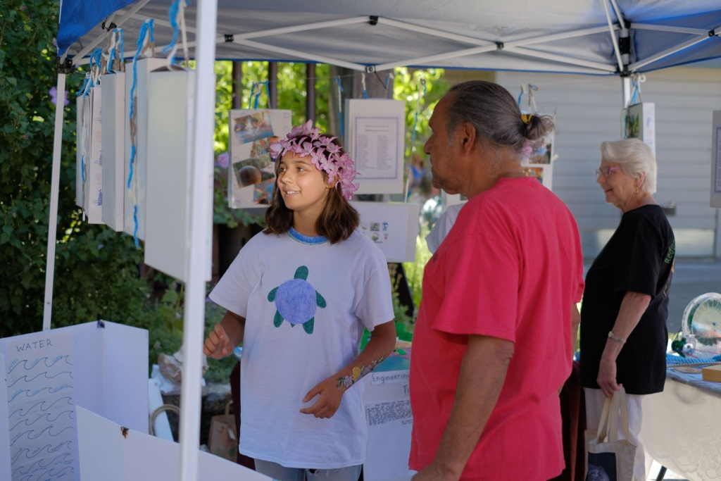
At the exhibit, citizens, shoppers, parents, and grandparents felt inspired by the Change Agents to commit in new ways, to better comprehend the plight of humanity, to appreciate their capacity to make a difference around the globe, and to support the local resolution for 100% renewable energy. Two weeks later, the Climate Change Coalition presented 200 petition signatures gathered at and beyond the farmer’s market booth. The City Council unanimously passed the resolution, with only one dissenting vote.

The following pages depict the song Island Call, choreographed by students and teachers to urge the human family to hear the call of disappearing cultures on shrinking islands.
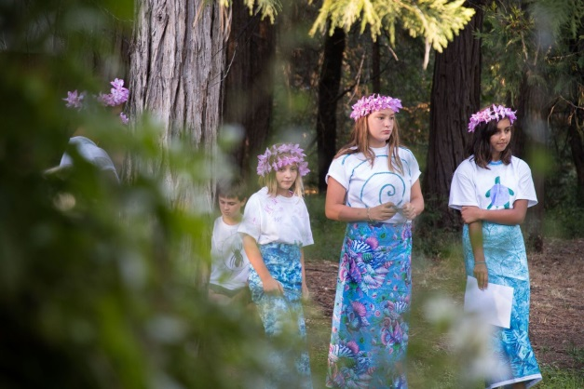

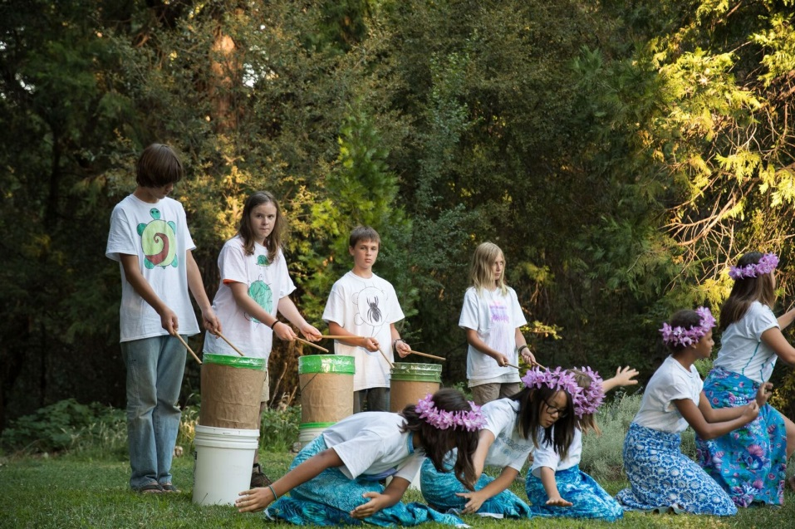

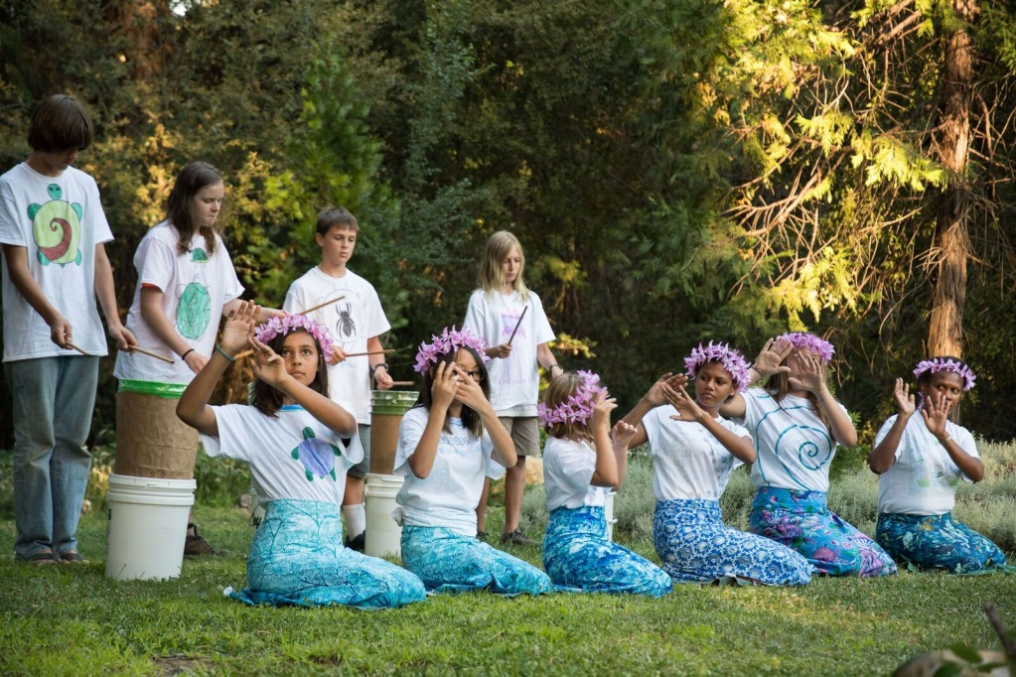
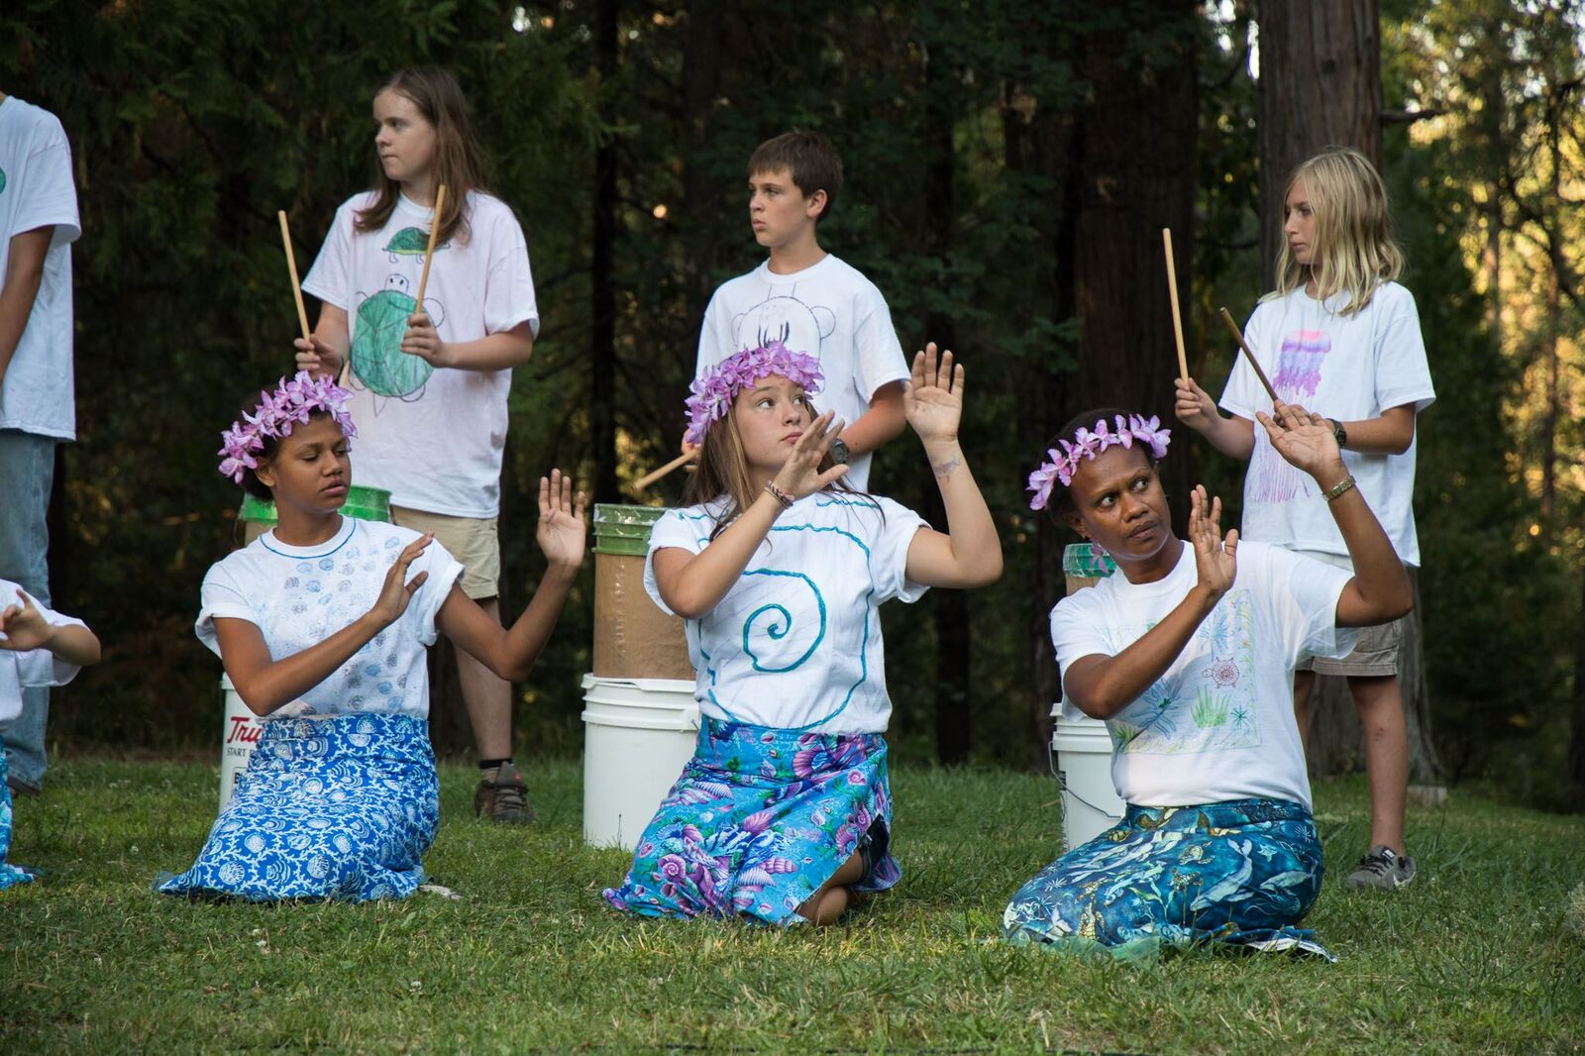

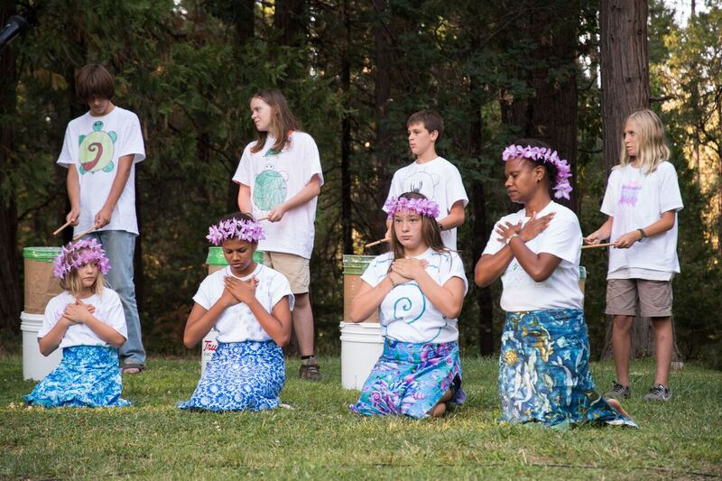

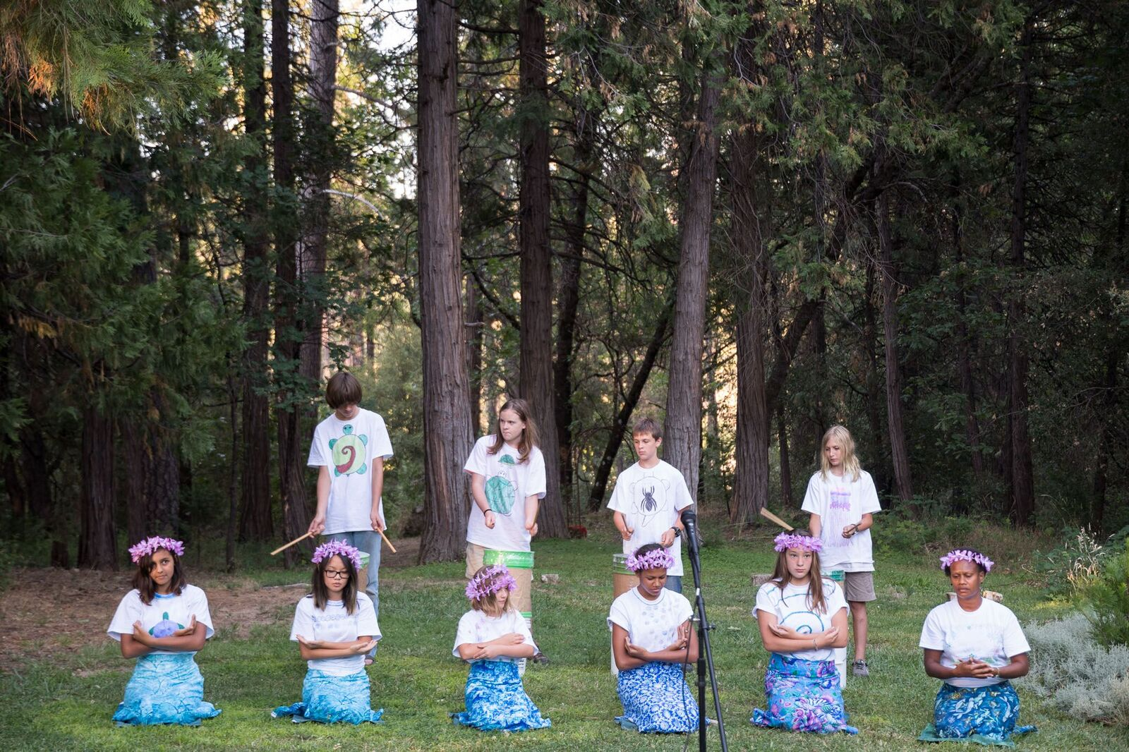

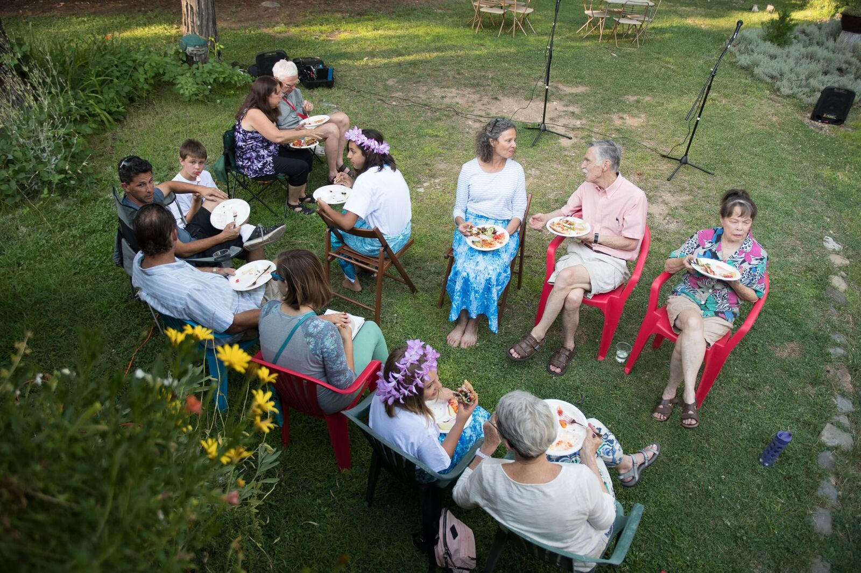

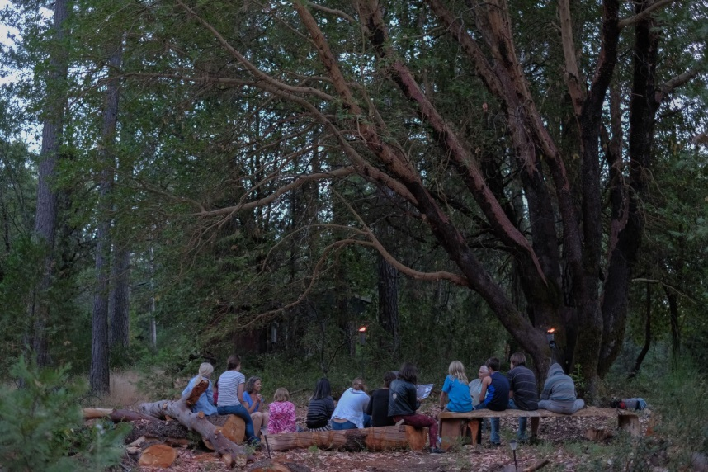

Changing Systems, Changing Hearts, Changing Lives
On the last evening, the Change Agents met to reflect under the madrone tree and quietly write the qualities they honored in one another. Each one would take away a keepsake letter from the others, noting the difference they had made in the lives of their friends. They had sent their collective voice out into the world, but tonight, they would know they had touched the lives of their peers. Each one would remember in years to come the impact possible through daily acts of empathy, respect and service. When at last the camp ended, some felt it difficult to leave the scene. Their hearts were connected to the league of species, to the human family and especially to one another as a diverse and cherished family of change agents.
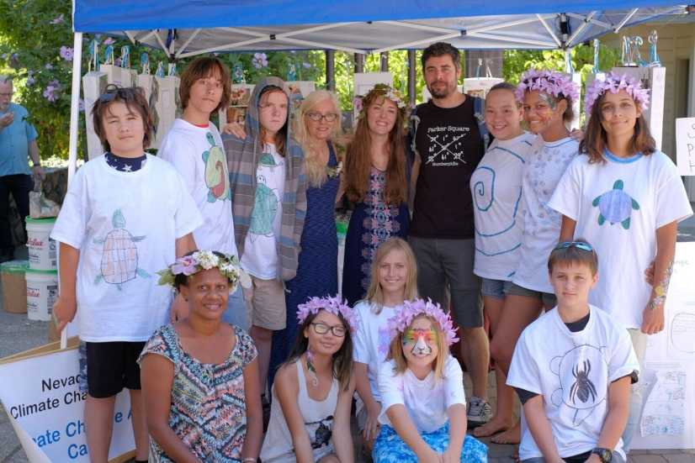

Outtakes
