Tomorrow’s Change Agents Got Off to an Early Start
(July 29, 2014) A new group of change agents was released into the community last Saturday, July 26—the Climate Change Agents. Sad to part, they left one another after days of intense activities that helped them create lasting bonds while appreciating the importance of not just learning but doing.
Co-sponsored by the Nevada County Climate Change Coalition Education Committee and Full-Circle Learning, the camp offered merit and needs-based scholarships to students from schools throughout Nevada County, from 4th through 8th grade, who spent their days and nights together engaged in projects that helped them develop service and advocacy skills.
Funding for the camp came primarily from the Forest Issues Group, California Solar and Electric, the Audubon Society, Rondal Snodgrass and other coalition members, and Sierra Harvest. In-kind support came from Nevada City Retreats, SPD, Grocery Outlet, Earth Justice Ministries and the Baha’i Community.
Many activities helped the youth create their own code of ethics and identify the “habits-of-heart” needed to put their ideals into practice, whatever the task. For example, before each meal, they nominated one another for practicing respect. Nominees had the pleasure of serving others the food at that meal. Other strategies as well influenced both the peer culture and strengthened the focus of the projects. For example, they timed their showers and made pie charts to measure their own water conservation and share the restroom use.
The two classes – the Advocates and Visionaries – prepared performances to teach the local community. They also used daily field trips and lesson plans as the basis for their letters, gifts and community exhibits, sharing methods to adapt to the drought, to conserve water and energy, to protect wildlife, and to care about the community of living things.
These change agents also learned about the relationship between social justice and the environment. As California Solar and Electric Owner Lars Ortegren sacrificed resources to help them create solar ovens, they found it difficult not to break the glass on some of the ovens. When it came time to sacrifice an oven, they still chose to give one to the Hospitality House to serve the homeless population, so several students immediately offered to sacrifice their oven instead.
The students also purchased and cooked a meal together and tracked the carbon miles of their meal, then visited a local farm, helped with the farm chores, and compared the carbon miles of the foods sold by the local grower. After also making a rain barrel and learning about gray water, they shared their wisdom about how to survive a drought with wisdom exchange partners in Haiti, at a village school where children help their subsistence farming community address the challenge of deforestation in the midst of a similar drought.
Daily presentations included Don Baldwin’s portrayal of John Muir, Rudy Darling’s owling tutorial, a lesson on rain barrels, and Lars Ortegren’s magnanimous efforts to help students construct the sturdy ovens. They also conducted research and offered service at Starbright Farms, compliments of Sierra Harvest, and learned to shop for and prepare a meal, then figure out their own carbon miles.
Performance art and music helped the children convey these messages to the public at a picnic in Pioneer Park and later at the Nevada City Farmer’s Market. They presented exhibits and, assisted by Kami Logan, Valerie Cassity and Moriah Fitzpatrick, performed several numbers: The March of the Hydrocarbons, Cool Summer Day, Changing Winds and Hoppy (based on the hit song Happy) to an audience of all ages.
Said one parent, “We live far from town. We were not sure we were doing the right thing to expose our children to nature as a first priority. Now that we see what they can do with this knowledge, we know for sure they are learning important lessons about life.”
The campers hoped their audience learned as well. As Jonathan Whitcomb closed the program, he urged, “We hope you too will become Climate Change Agents.”

(Photos and captions follow.)

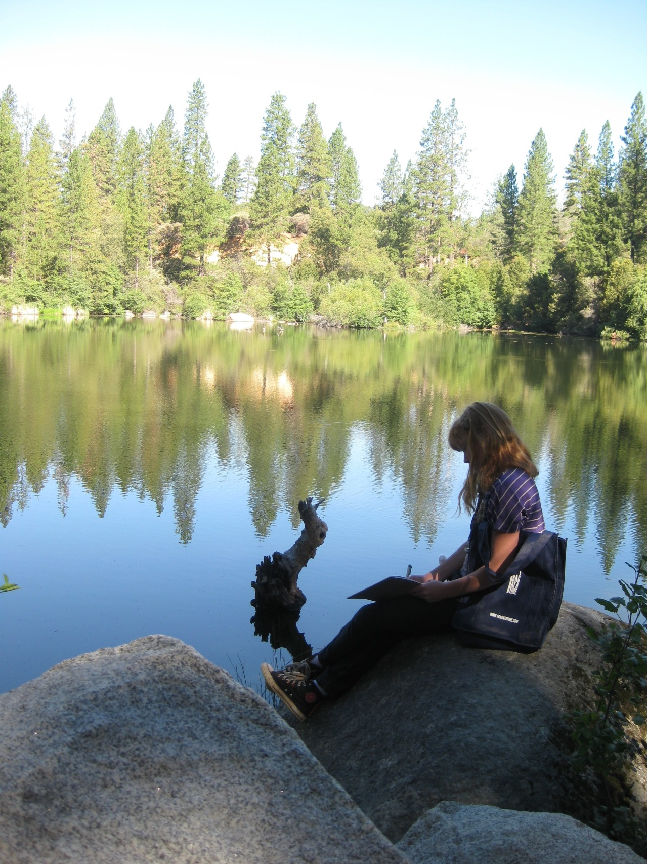
Rachael Triglia takes note of the waterfowl on Hirschman Pond. She developed her own catalogue of birds over the course of the camp.

Photo Essay

Nehemiah Lopez and Rhiannon Triglia help identify which plants to pull while weeding okra at Starbright Farms, where they learned how small farms use drip irrigation to evade the devastation of the drought. The climate change agents helped weed a row and pull turnips in exchange for their farm tour. They also identified the knowledge, personal “habits-of-heart” and practical skills needed by farmers to develop sustainable 3-acre farm.
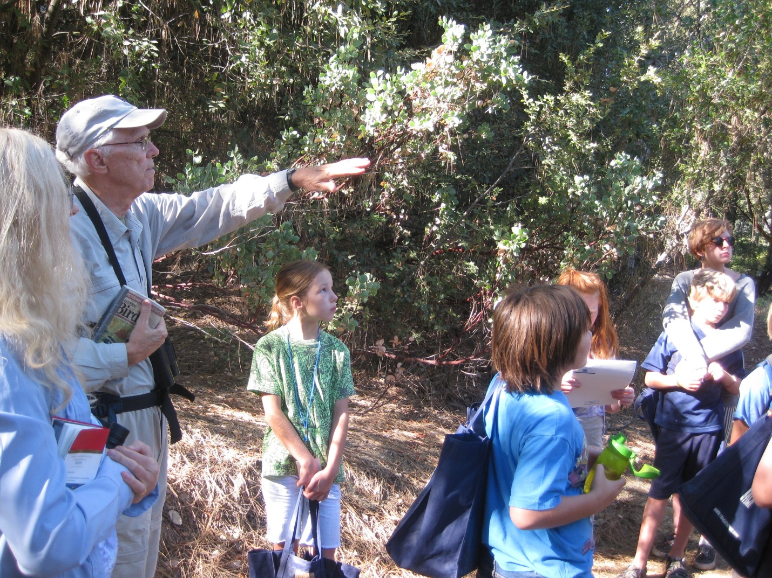

Don Rivenes pointed out climactic impacts on habitats, such as shifting food sources and altered migration habits, as he helped youth seek out birds and water fowl on Hirschman Pond.
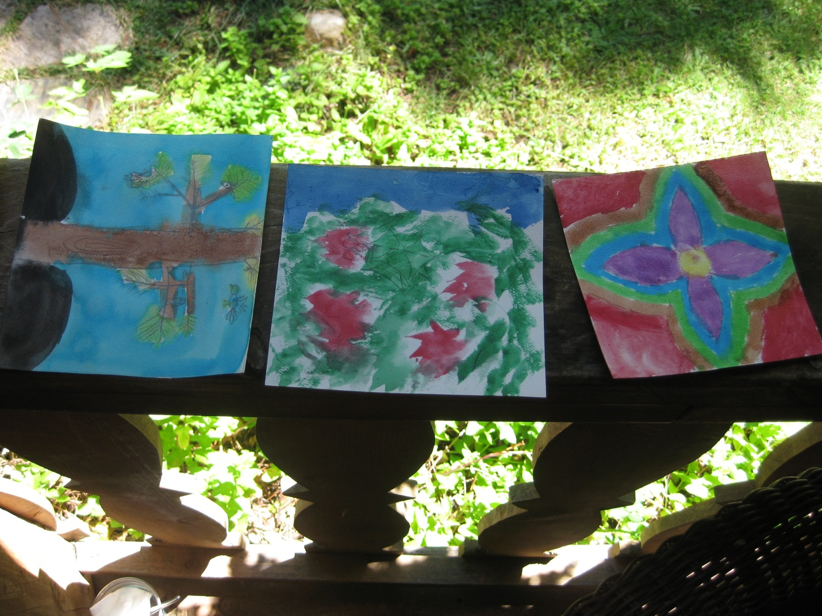
Students took a “roll call” walk through a neighborhood bordering a forest, to seek out human systems that interact with natural systems. They each found something precious to them and painted what they want to protect in nature. The watercolors became gifts for teachers and guest presenters.

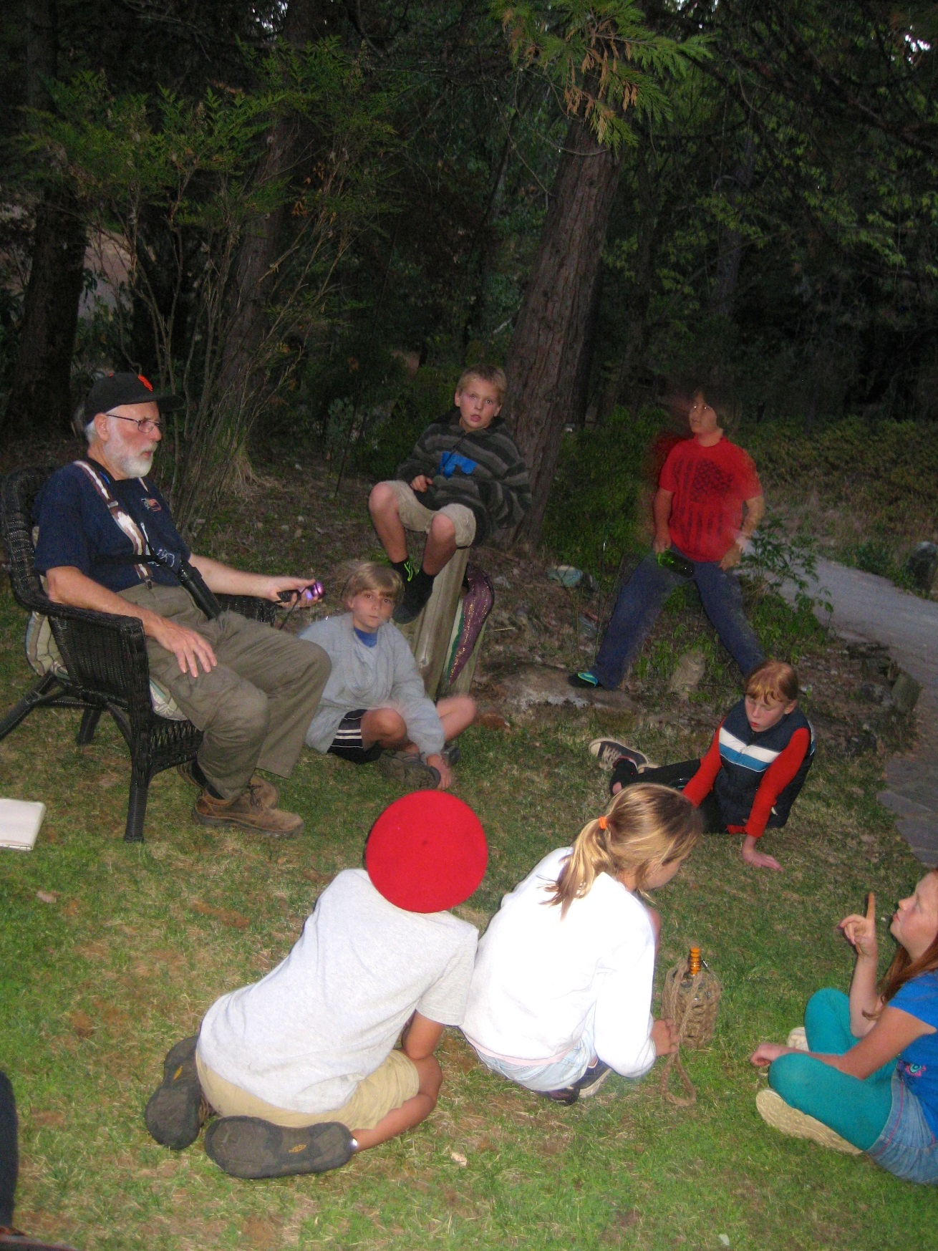
Rudy Darling explained the wondrous diversity of the owl population and taught his repertoire of owl calls and led a tiptoe down to the chicken coop, where the group rousted out a couple of screech owls.
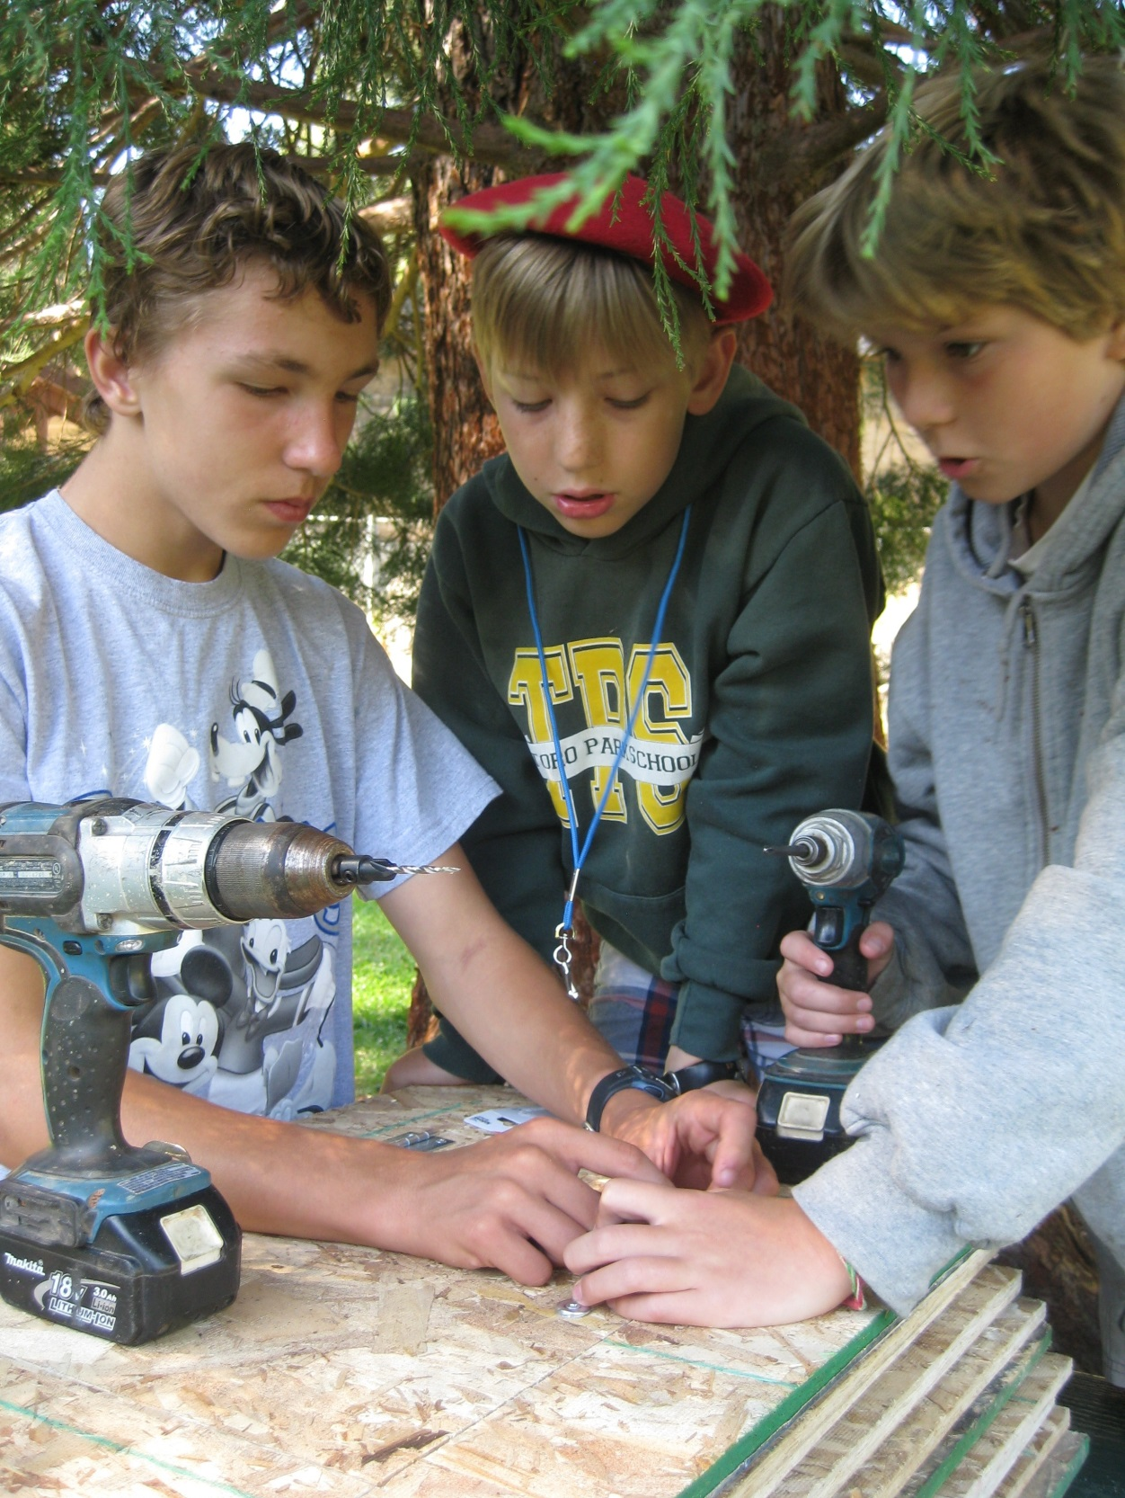
During an assembly line production of solar ovens, Justice Coray, Jonathan Whitcomb and Skylar Hancock problem-solved to drill on hinges without breaking the glass on the lid. Lars Ortegren, of California Solar and Electric, donated materials and designed the ovens. Students learned to use them at home and donated one to Hospitality House for use in feeding the local homeless population.
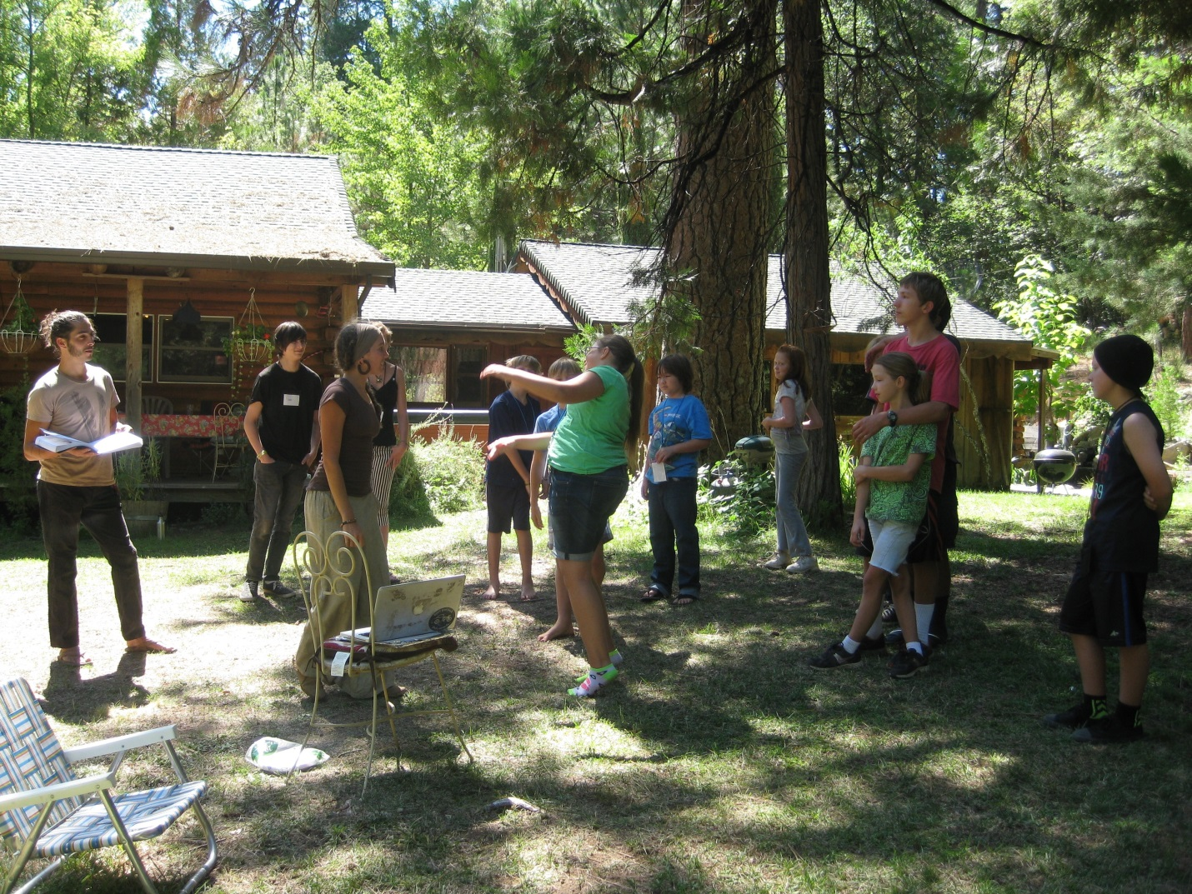

Rehearsals for four performance art acts helped students see how they could inspire action through the arts. Kami Logan choreographed a number from the Climate Change Agents curriculum, “March of the Hydrocarbons.” Moriah Fitzpatrick narrated.

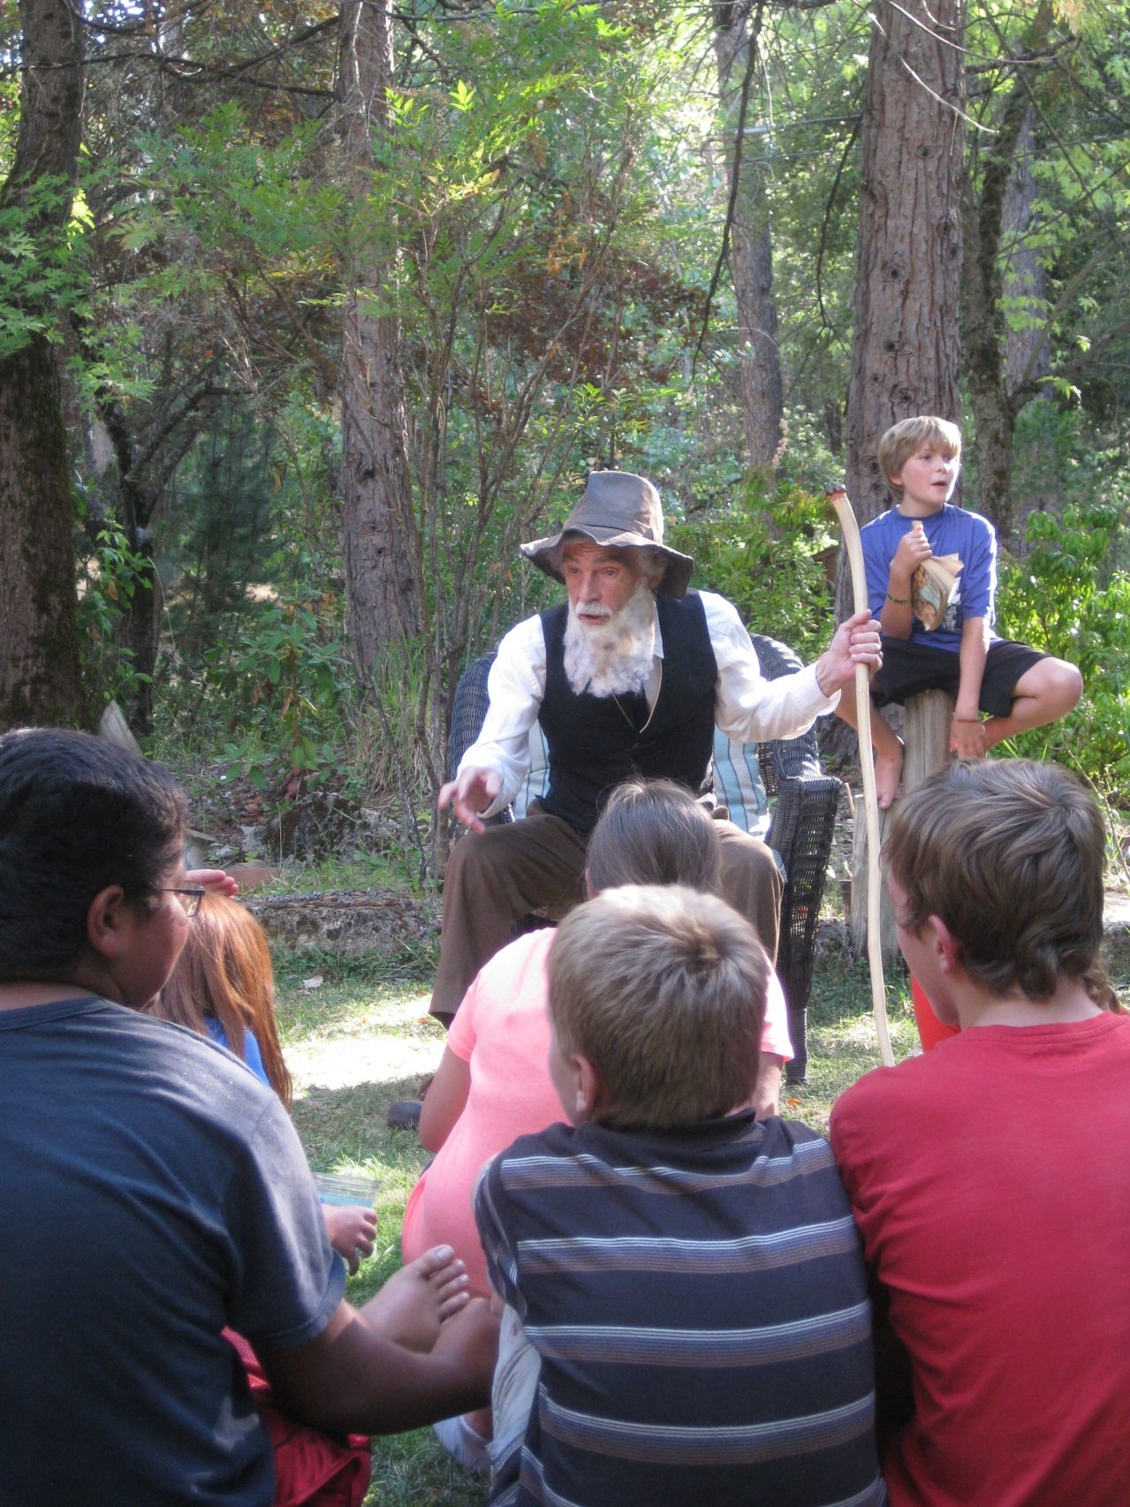
A surprise visit from “John Muir,” a.k.a. Don Baldwin, held special meaning because students had completed a conflict resolution activity, learning to face academic controversies over the glaciers or resolve political frays such as Hetch Hetchy while striving to maintain respect the alternate perspective.
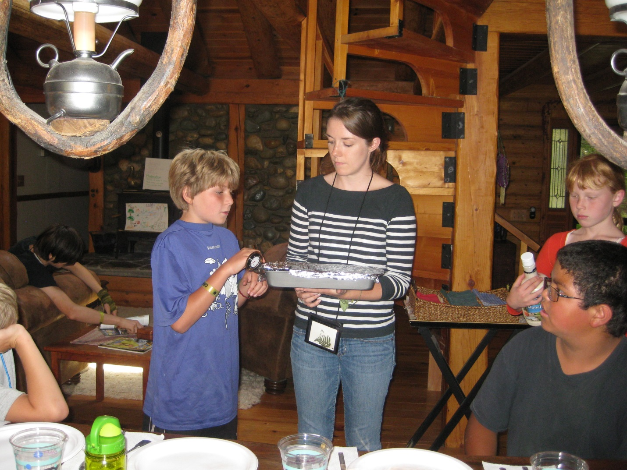

The Visionaries and the Advocates classes demonstrated to each other concepts relating to climate change. Here, Advocate Skylar Hancock shows the condensation ceiling on a pan of greenhouse gas brownies.
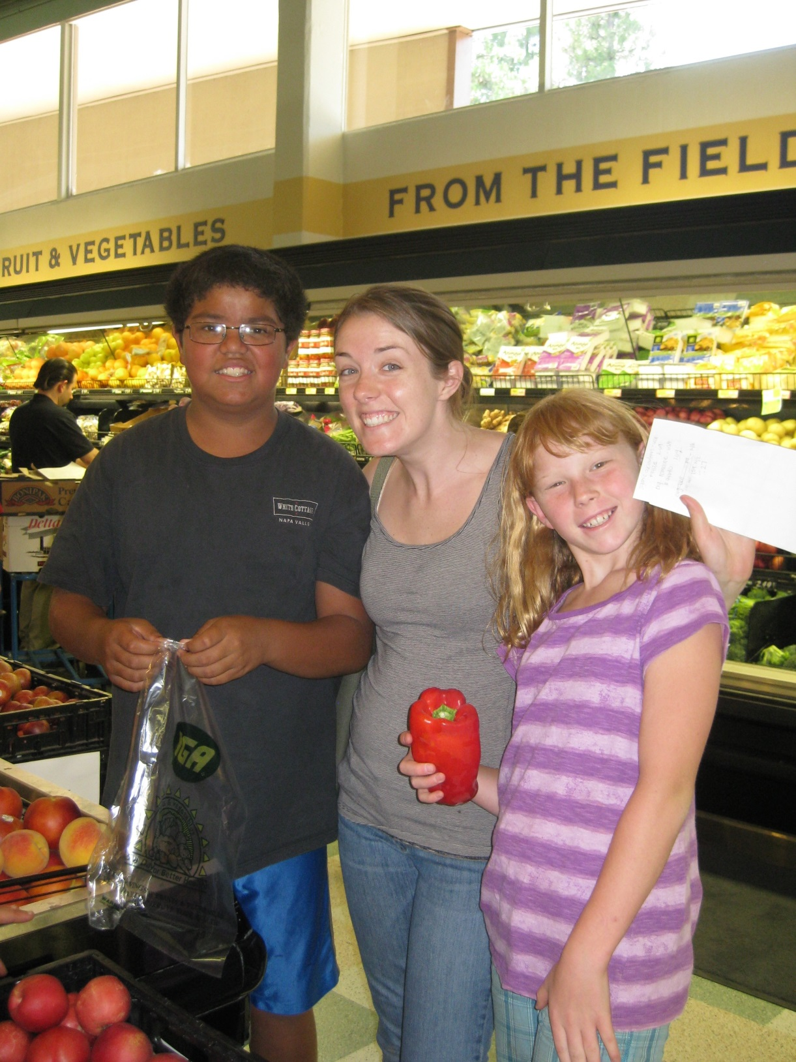
Shopping teams searched for assigned food groups, budgeting their funds and nutrition choices before making dinner together. Next, they faced the challenge of tracking the transportation miles and carbon units of their meal. The next day, they would compare that with miles traveled by produce purchased at the local farm, which only exports food within a ten-mile radius. What an epiphany – their food traveled thousands of miles, compared to ten!
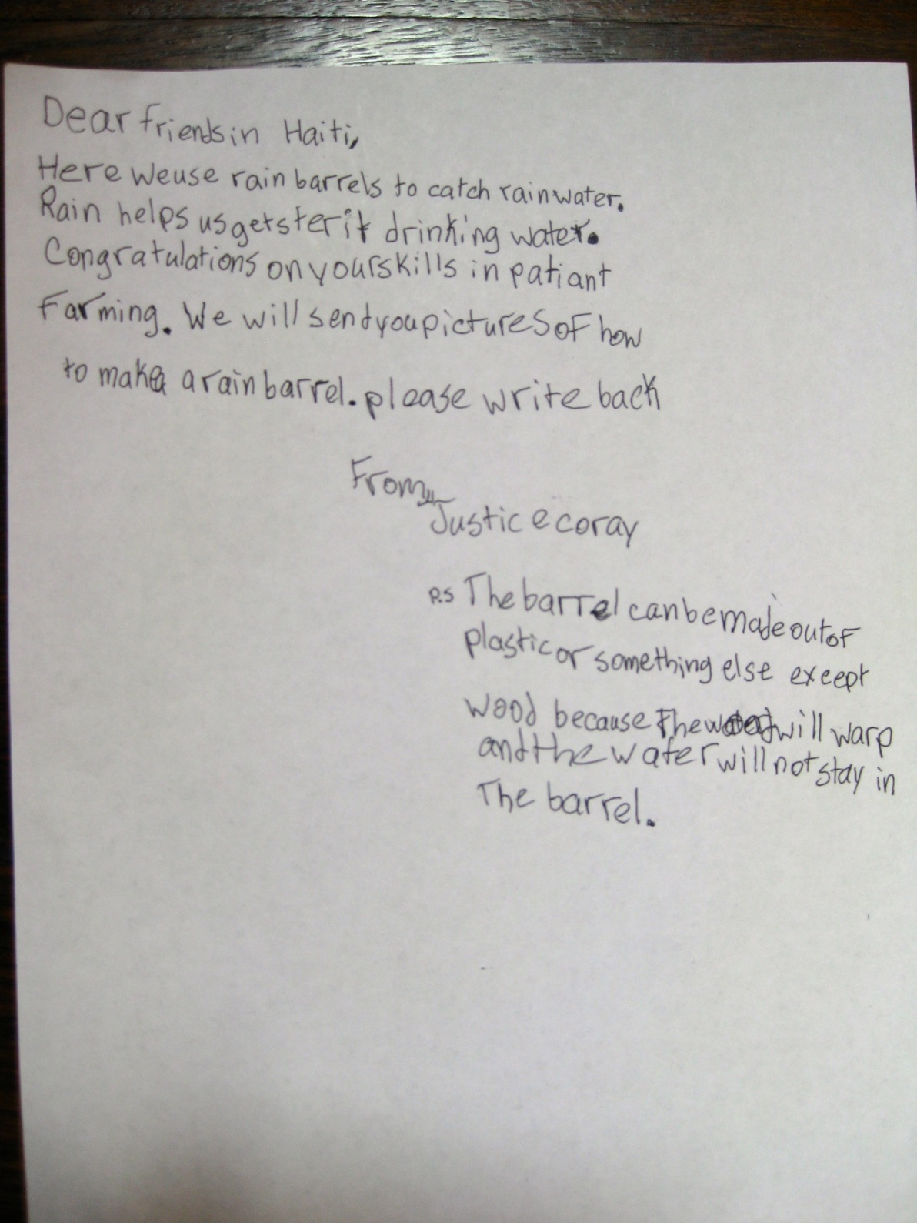
Students learned about the deforestation projects of a village school in a subsistence farming community in Haiti and read the email from their liaison, who expressed the concerns of the farmers about the dire need for rain. They shared their own wisdom in return about what farmers here are doing to address drought conditions. They addressed internal and external resources needed by climate change agents.
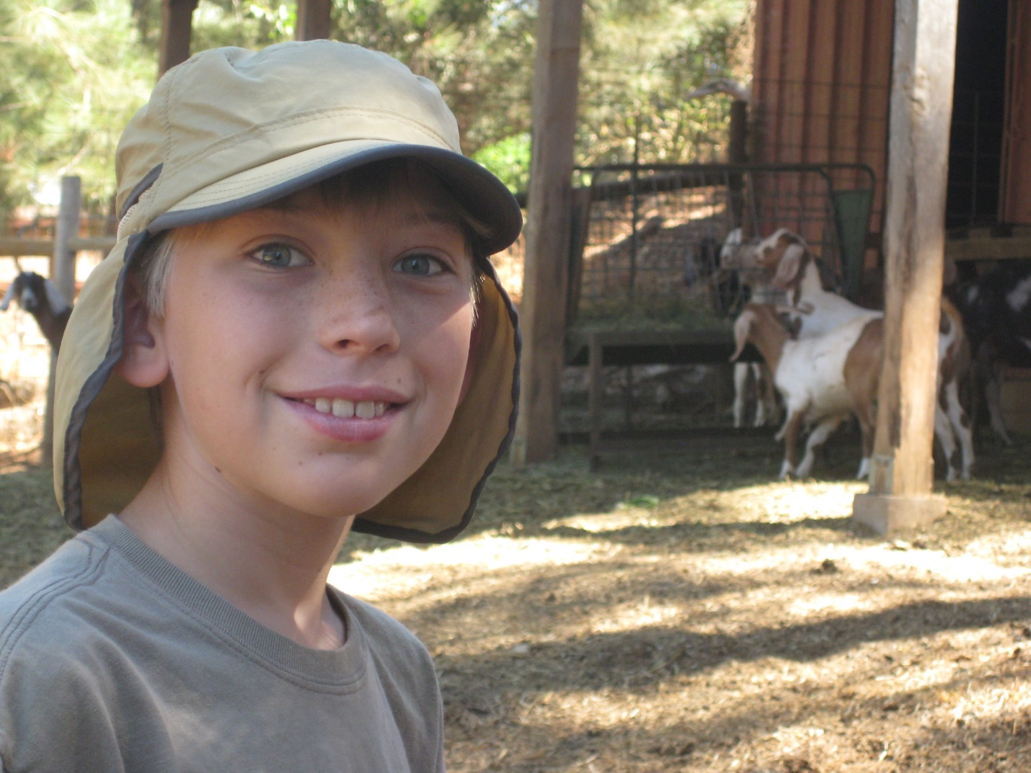
Starbright Farms told about the goat shares that allow small farms to raise a herd and a whole community to share both the benefits of the milk and the responsibility for the goats. The farm trip was sponsored by Sierra Harvest. Here and throughout the week, Jonathan Whitcomb and his fellow visionaries made note of ideas to share in their wisdom exchange with Haiti, in their exhibits at the Nevada City Farmer’s Market, and at the Nevada County Climate Change Coalition picnic.

A

A

This
Thi
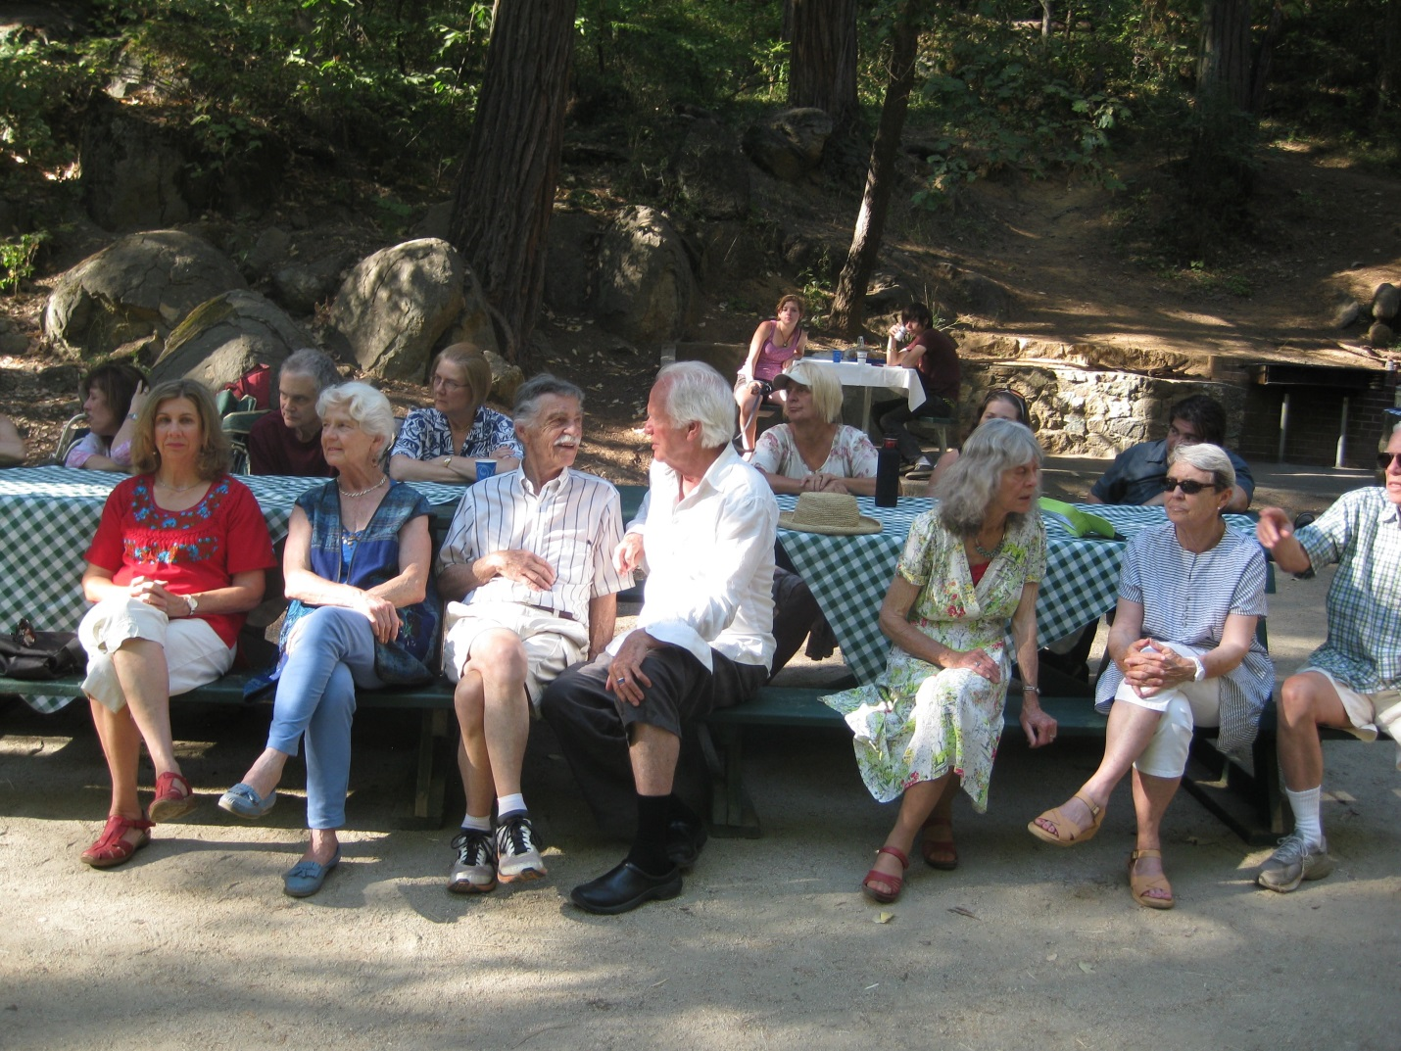
NC-CCC Members relaxed before the performance. Joanna Robinson, left, would receive her solar cooker for the Hospitality House.
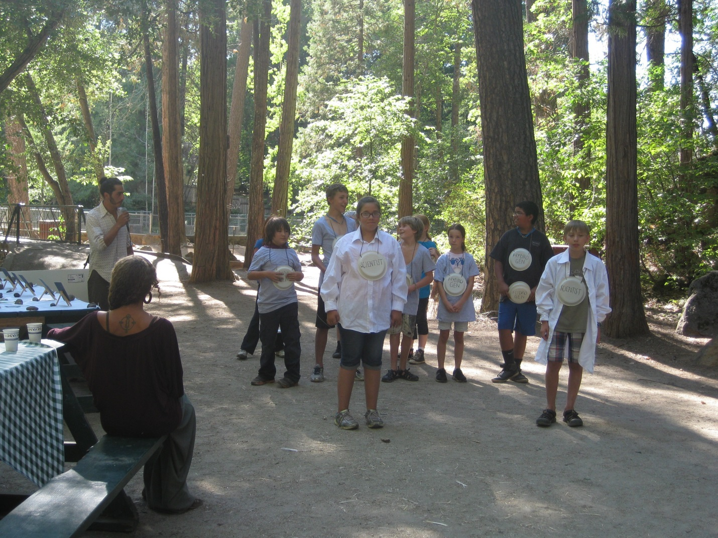
The students formed the shapes of various hydrocarbons during their performance, learning to share the stage with wind, solar and biomass energy.
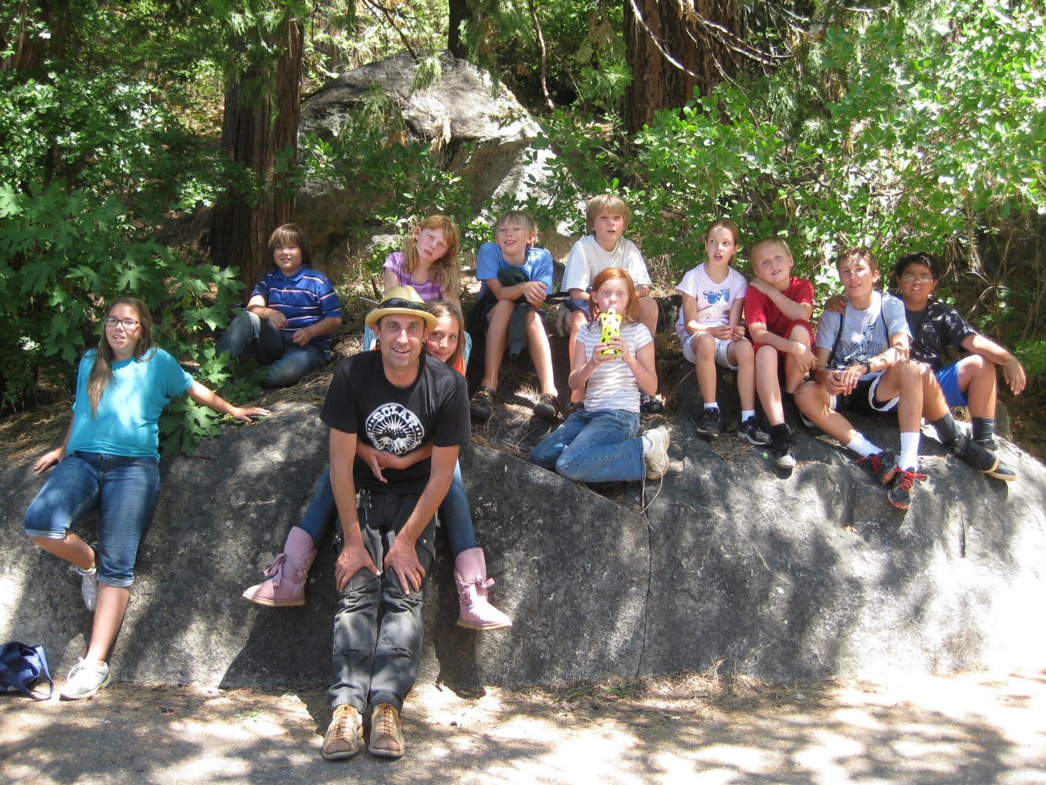
Students gathered at Pioneer Park with Lars Ortegren and his daughter Rowen after a day of making solar ovens. Though all came from different schools, they all expressed a longing to maintain their bonds and return next year.

