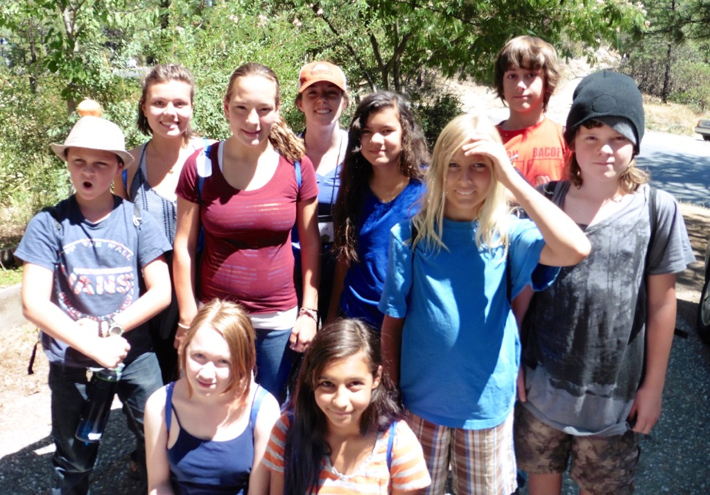

Nevada County Climate Change Coalition’s
CLIMATE CHANGE AGENTS CAMP 2016

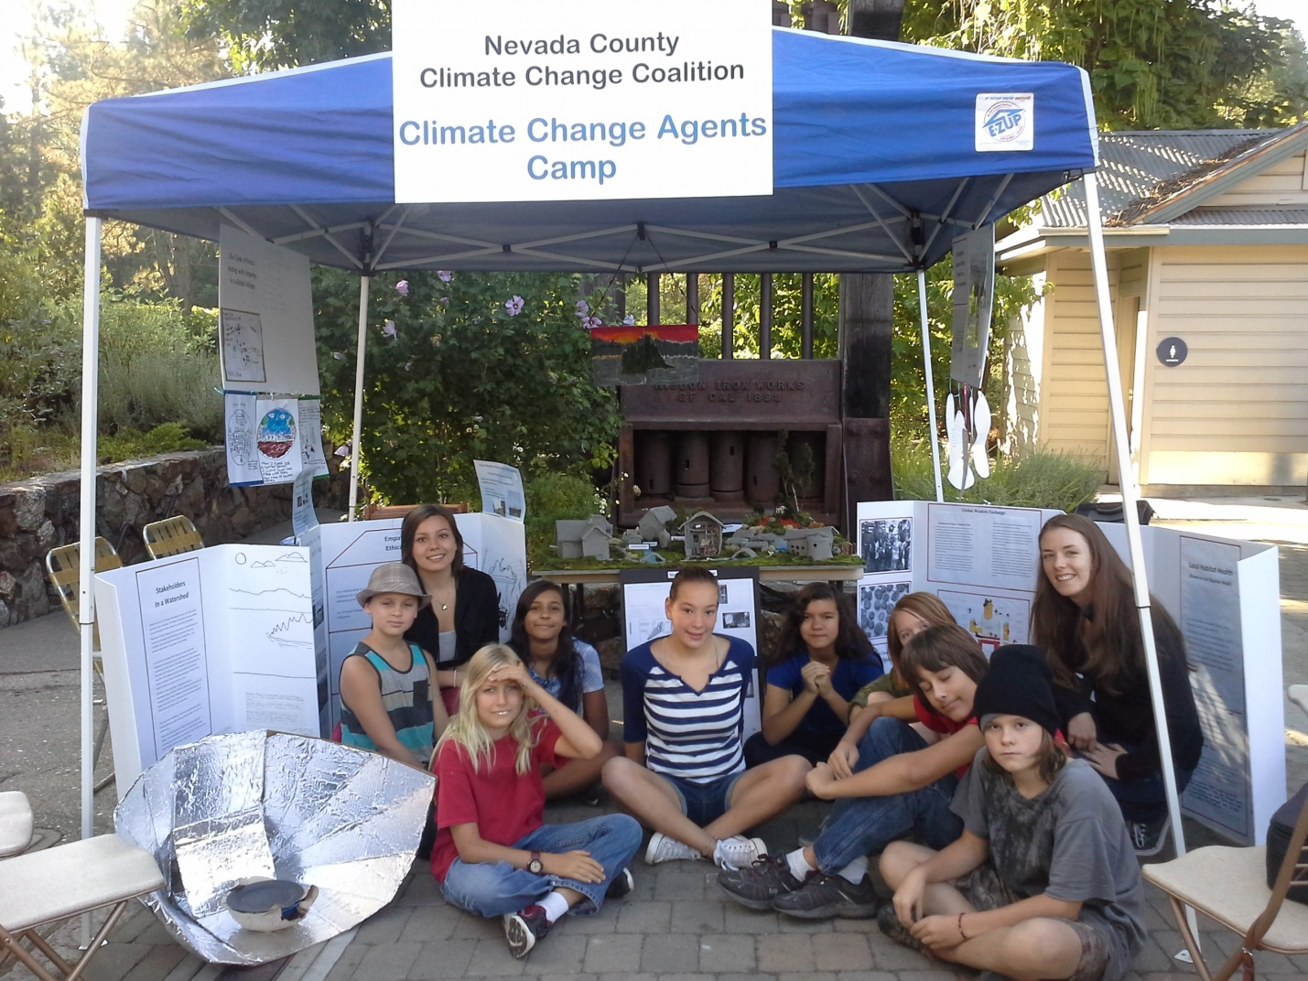
“Never doubt that a small group of thoughtful, committed citizens can change the world; indeed, it’s the only thing that ever has,” Margaret Mead reminded us.
Young change agents had a chance to discover the reality of this statement firsthand—and to consider their potential as change agents—at the Climate Change Agents Camp, in Nevada County California in August, 2016.
The change agents spent five days and four nights learning ways to create an Ethical Village based on empathy. By their actions and through their projects, the overnight camp’s 10-14 year-olds defined the essential role that empathy plays in creating an ethical local and global village.
During a week of nonstop activity, the change agents:
- Established the need for a group code of ethics guided by empathy for one another and also empathy for diverse species, peoples and perspectives as all work toward climate change prevention, abatement and adaptation.
- Learned science experiments to demonstrate for others the principles of increasing temperatures, rising tides, greenhouse gas effect.
- Worked in teams (focused on plants, trees, animals, birds and amphibians) to complete field research, evaluating the health of a local riparian habitat where rising temperatures had displaced native birds, impaired plant health and increased bark beetle and wildfire danger (and compared two other local habitats as control groups).
- Learned how to call owls and studied local owl habitats.
- Visited a reservoir and practiced empathic problem solving as hypothetical watershed stakeholders during a drought.
- Learned how to repair a hydrology system and how to use solar and water power as energy.
- Designed clay-based architectural model of an ethical village with energy-efficient straw bale homes after spending a day on a straw bale property off the grid.
- Explored the importance of protecting pollinators and their habitats; studied use of biodiversity in gardening to attract pollinators to an orchard.
- Conducted a wisdom exchange with Tanzanian students based on the relative carbon emissions benefits of dung patties versus solar cookers. Learners in both countries explored the new cooking fuels to keep girls in school, rather than having them continue to collect firewood all day while deforesting the landscape.
- Created and tested solar cookers and sent exchange to Tanzania, along with batik to share study of vulnerable birds.
- Created art exhibit for long-term community exhibit showing problem-solving solutions for water stakeholders.
- Made videos encouraging conscience-based voting.
- Ultimately, taught the public how to restore habitats, abate climate change and develop compassion, ethics and empathy, along with knowledge and skills needed to assist climate change victims.
- Advanced these messages by creating musical composition, choreographing a dance performance, preparing speeches, and giving tours of standing exhibits and a clay village at a farmer’s market and upcoming fairgrounds exhibit.
- Made videos encouraging conscience-based voting.
- Planned future careers, inspired by role models in multiple professions, including technologists at a company that develops early warning systems for flooding.

All these service projects the Change Agents achieved with one week’s work! Through front page newspaper coverage in the Union, social media coverage through multiple organizations, and onsite exhibits or performances at four community hubs, their messages will reach thousands by Election Day.
The participants had been referred by teachers at various schools, as high-potential students and potential leaders of their generation. They practiced their interpersonal skills each day, recognizing empathy in one another and performing acts of service. Their first act of empathy was to empathize with the sense of those losing culture and land due to climate change.
This experience of life on a shrinking island drove their code-of-ethics, which directed their own behavior and influenced their sense of how to work together to create an ethical village.
After the camp, one commented, “I never imagined I could ever learn so much.” A parent of another said, “My child has come forward every day with new information and new excitement about helping others. It’s amazing.”
Respondents indicated “I agree” (as opposed to “Not so much” or “I disagree”) when given the following anonymous survey questions:
- I understand more than I previously did about how to help those suffering due to climate change.
- I feel that my talents and actions can help teach the community and can make a difference in the lives of others.
- I better understand how to solve problems in an ethical village in ways that help the local or global community.
- I believe that our wisdom exchange can make a difference in the lives of Tanzanians.
After the camp, one commented, “I never imagined I could ever learn so much.” A parent of another said, “My child has come forward every day with new information and new excitement about helping others. It’s amazing.”

Photo Essay
Below: Field notes, straw bale cottage, architectural design for solar panels
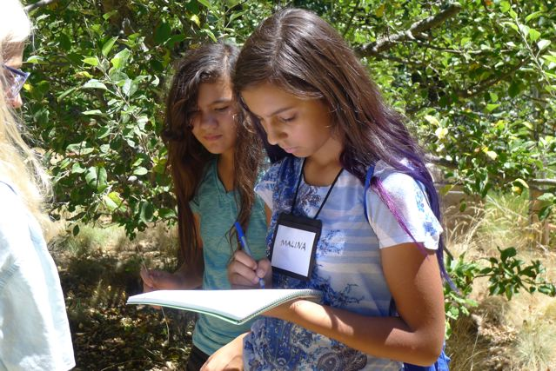
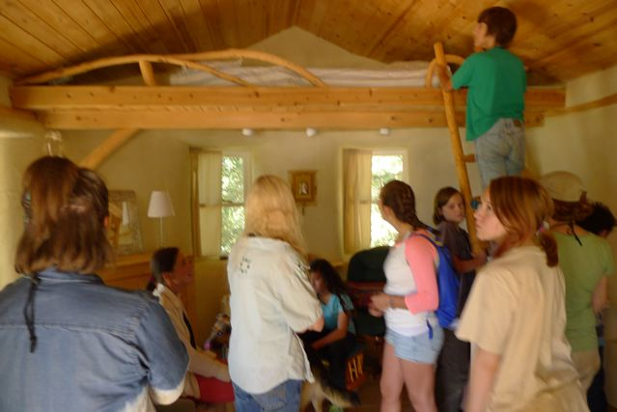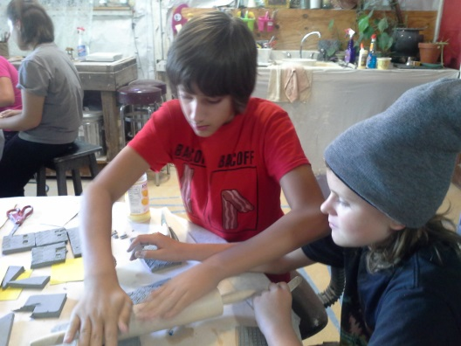

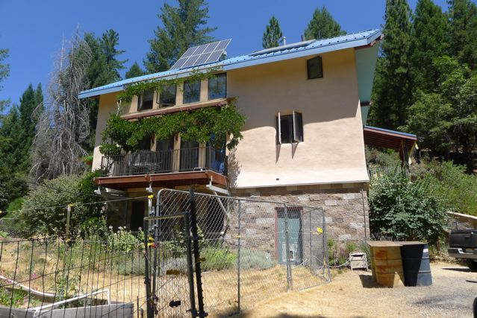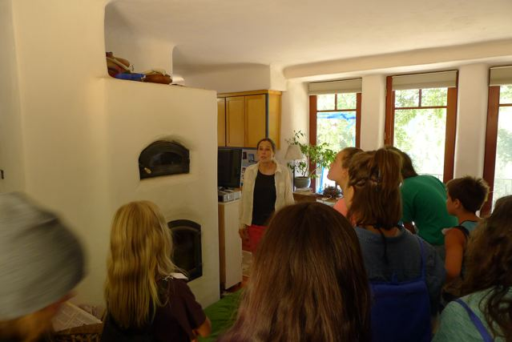

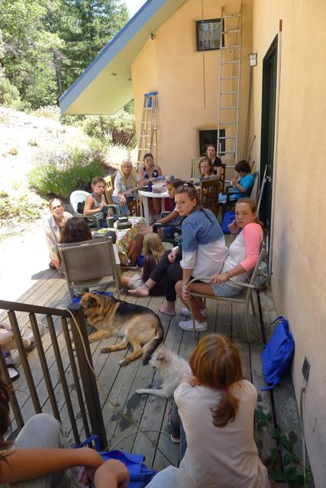 | The youth developed a code of ethics to direct personal actions, community interactions, research within an ecosystem, lifelong career choices and problem solving with wisdom exchange partners in the global village. They worked toward a high goal: to teach members of the community not only how to advocate change but to create climate justice for those already suffering due to the effects of climate change.  In the process, they met individuals who had sacrificed time and effort to make positive choices that benefit the living beings who need a healthy climate.  Here, they rest after their work at a straw bale home site where hydrology contributes to energy-efficient design.  Above left, the pollinator garden, solar panels and orchard also come into view.

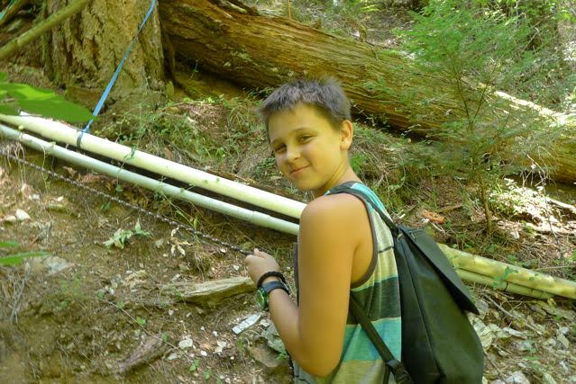
Checking on the hydrology project necessitated hoisting yourself to the downhill via cable. The change agents, including Tanner, showed they could endure rugged conditions to create energy-efficient systems.
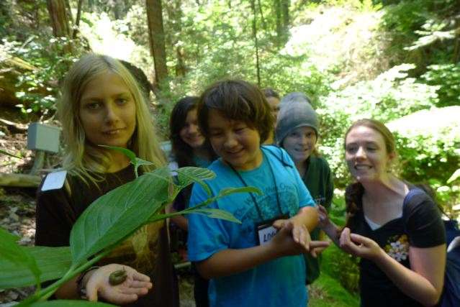
Sammy Eckl, Logan House and Kaiden Johnson showed teacher Katie Smith the slugs and lady bug colonies they discovered in a protected riparian habitat.

Sammy’s hummingbird photo informed a discussion about pollinators. Rene Sprattling’s photos of bee-friendly flowers taken in the garden near the orchard where Chris Newsom and Ruby Chow gathered insights that would inform the clay village project.
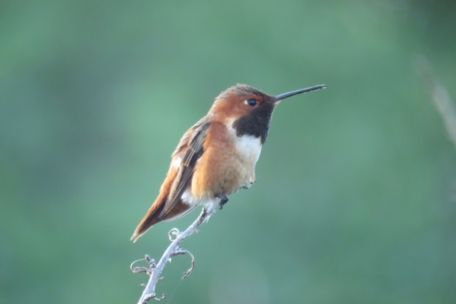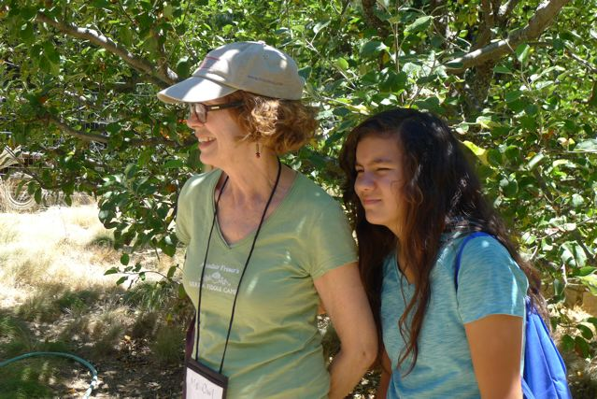
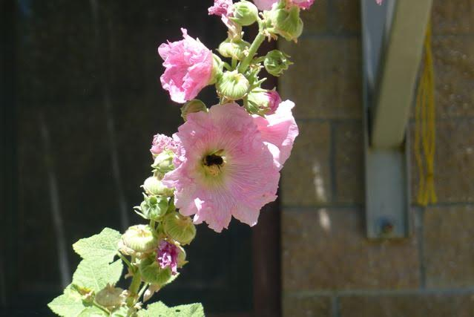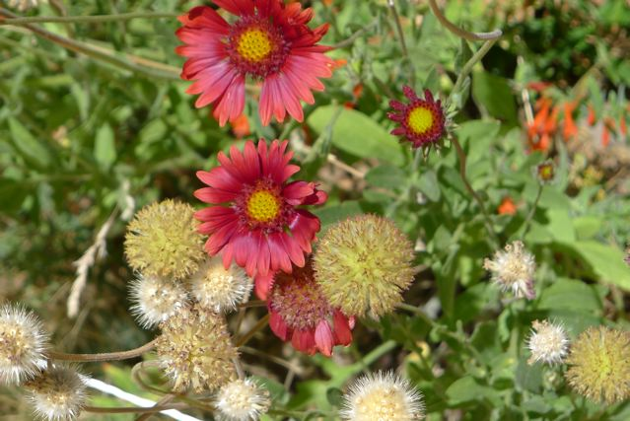

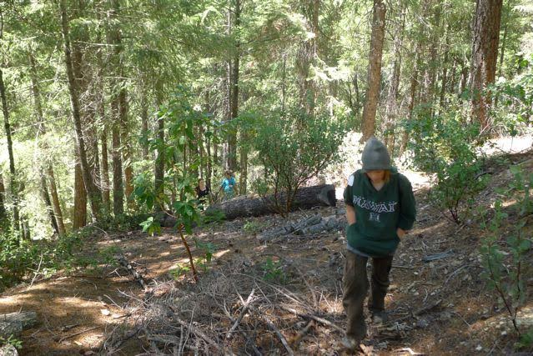
Daily hikes helped students compare various habitats and observe evidence that climate change had influenced the sustainability of some species more than others. Above, Kaiden Johnson plays a specific role as he walks on a trail.
Sixteen bird species affected by climate change in the region became a primary topic of concern. The fleeting appearance of the Canada goose and the juvenile screech owl, below, were no match for the greater numbers of birds Sammy had photographed in other parts of California. The group “conversed with” this screech owl for some time, with help from expert owler Rudy Darling.

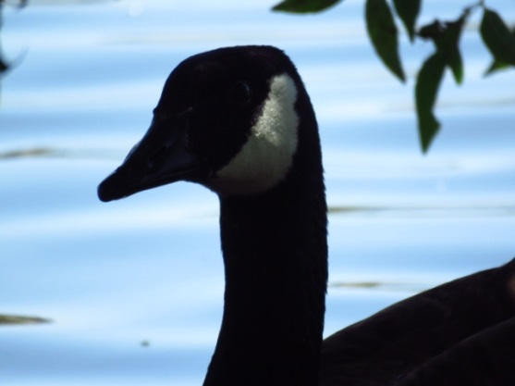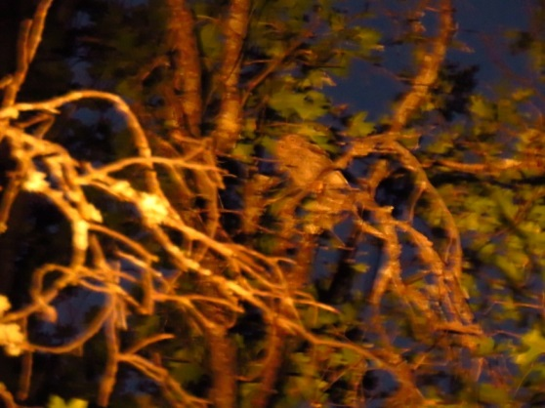

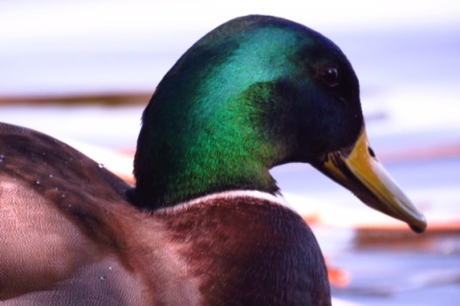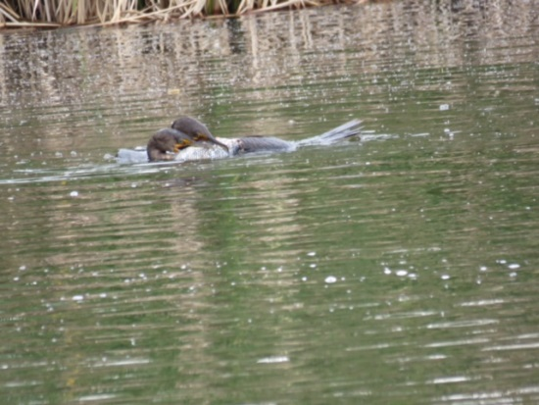
Hirschman Pond, in the past, served as prime habitat for water fowl more elusive to this year’s hikers. Just as telling as the birds appearing in the habitat, the change agents noted those absentees kept away by rising water temperatures and algae masses that had replaced pond food. To name just two species, they expected to see mallards and double-breasted cormorants like those above (photographed in distant waterways, fighting over a fish).

The mourning dove, a common feature of the ecosystem, also stayed away, its cooing song left unsung. The rufous-sided towee also appeared not in its prime habitat but in a preserve many miles from home. (All bird photos by Samuel Eckl.)
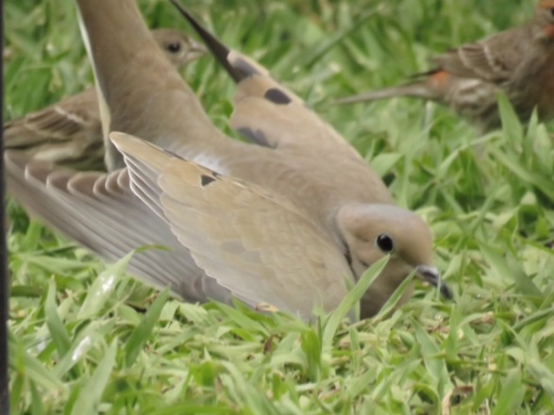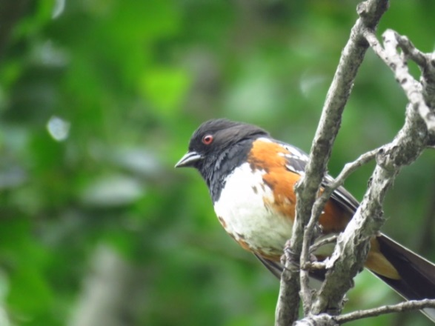

An osprey made its nest on the lakefront at 3500 feet, although it did not appear on the lower riparian walks. Sammy, who took all the bird photos, wrote a violin composition and story called ‘Plight of the Osprey,’ telling about a mother who traveled far to find food for her chicks.
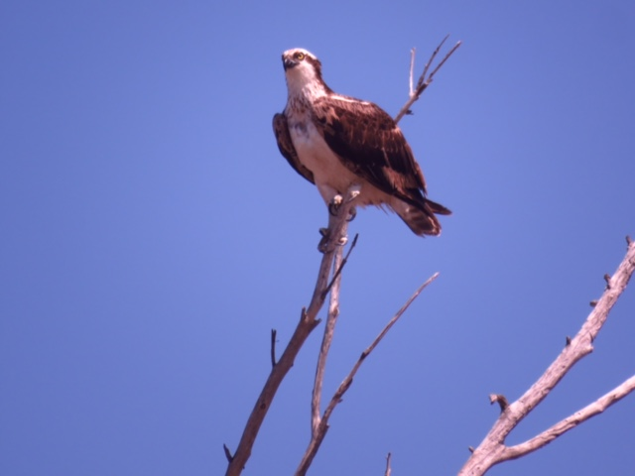
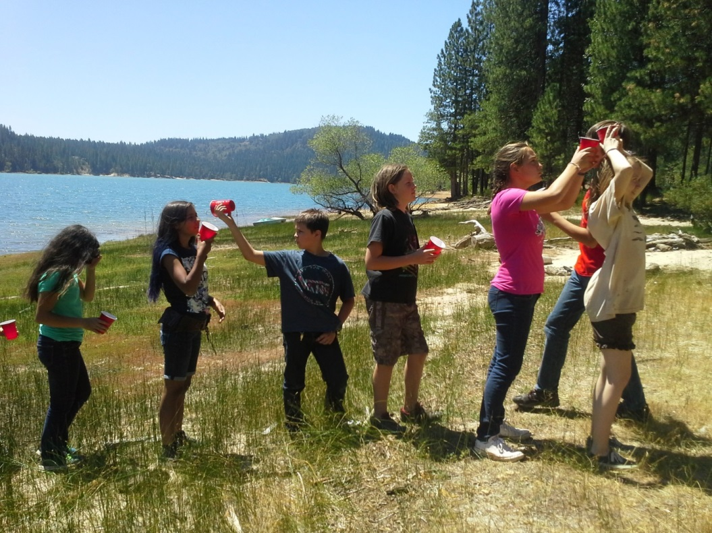
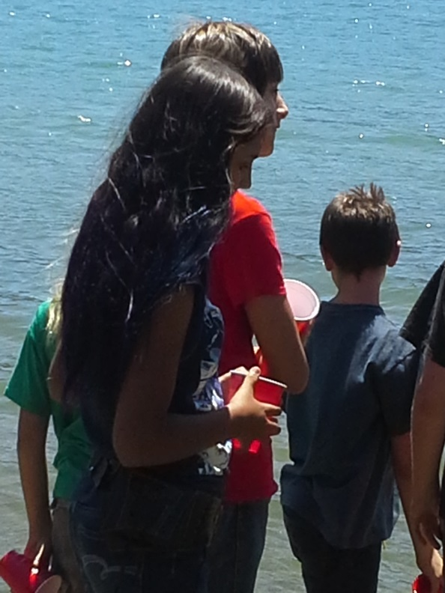 | Even at the slightly higher elevation, Scotts Flat Reservoir still showed signs of bark beetle and other climate change impacts. Here, the change agents learned to recognize stunted versus healthy trees and several samples of beetles. They heard presentations about watershed issues from NID representatives and had the chance to experience the difficulty of moving snowmelt from the mountains to sea level without losing precious water resources along the way. Neysa King coordinated the activities with colleagues Jim and Rem, supported by Vanita as the driver.  At camp, the youth had already resolved conflicts during a drought among hypothetical watershed stakeholders such as farmers, business owners, indigenous people, conservationists, recreationalists and water managers.

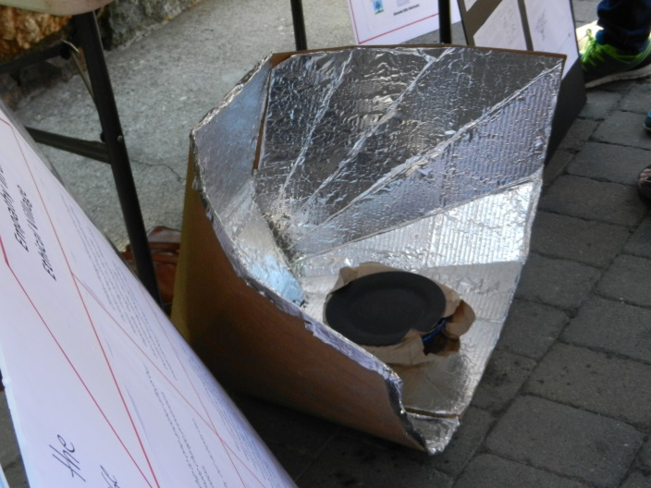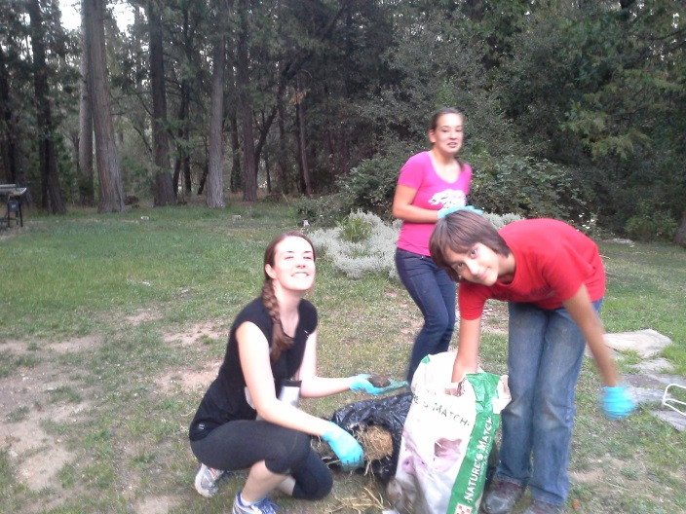
Reed Hamilton and Alice Burkner, of Solar Cookers International, taught efficient ways to build a portable solar cooker. At the farmers’ market, the change agents displayed the solar oven style they had tested and that they shared with their Tanzanian wisdom exchange partners. Above, Zach Damewood and Lucy Carson compared solar cookers with dung patties as a fuel source, to empathize with the community training experience of the Tanzanian students.
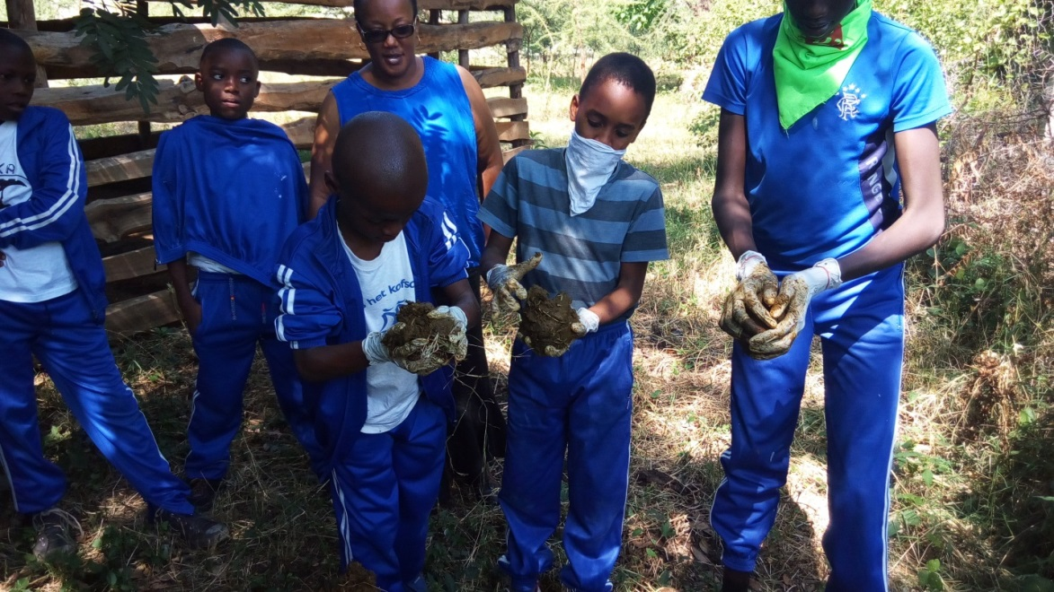
Students at the Dinka School, in Arusha Tanzania, spent several months planning what they would do to contribute to the wisdom exchange. Here, they demonstrate how to make the dung patties for their community, to keep girls from having to stay out of school to collect firewood for cooking fuel and thus deforest the land.

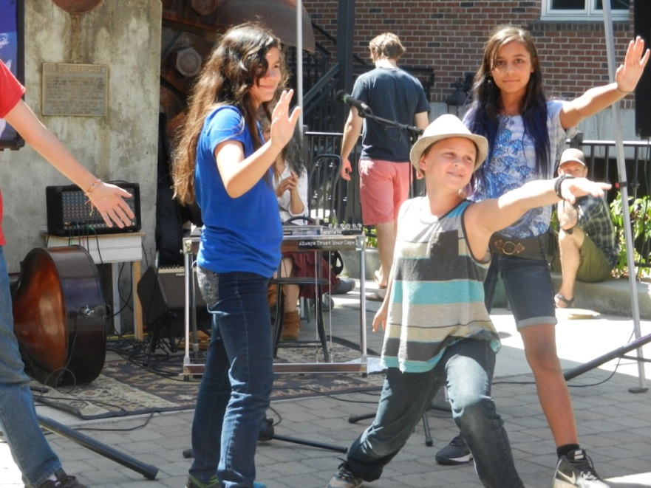
The change agents accomplished a number of tasks over the course of five days and four nights at the camp. They achieved their ultimate goal of operating a booth and completing their performance at the Nevada City Farmer’s Market, where they gave tours to teach the public how to both reduce and cope with the effects of climate change by creating a more ethical theoretical and actual village.
Zach Damewood, Ruby Chow, Tanner Delgado and Malina Mitchell danced to inspire the crowd to think about the connection of all living things and to urge others to aspire to greater concern about the human family as they think about climate justice. The song ‘I Apsire,’ posits the idea that the human family is one and we need keep the fire of love alive.

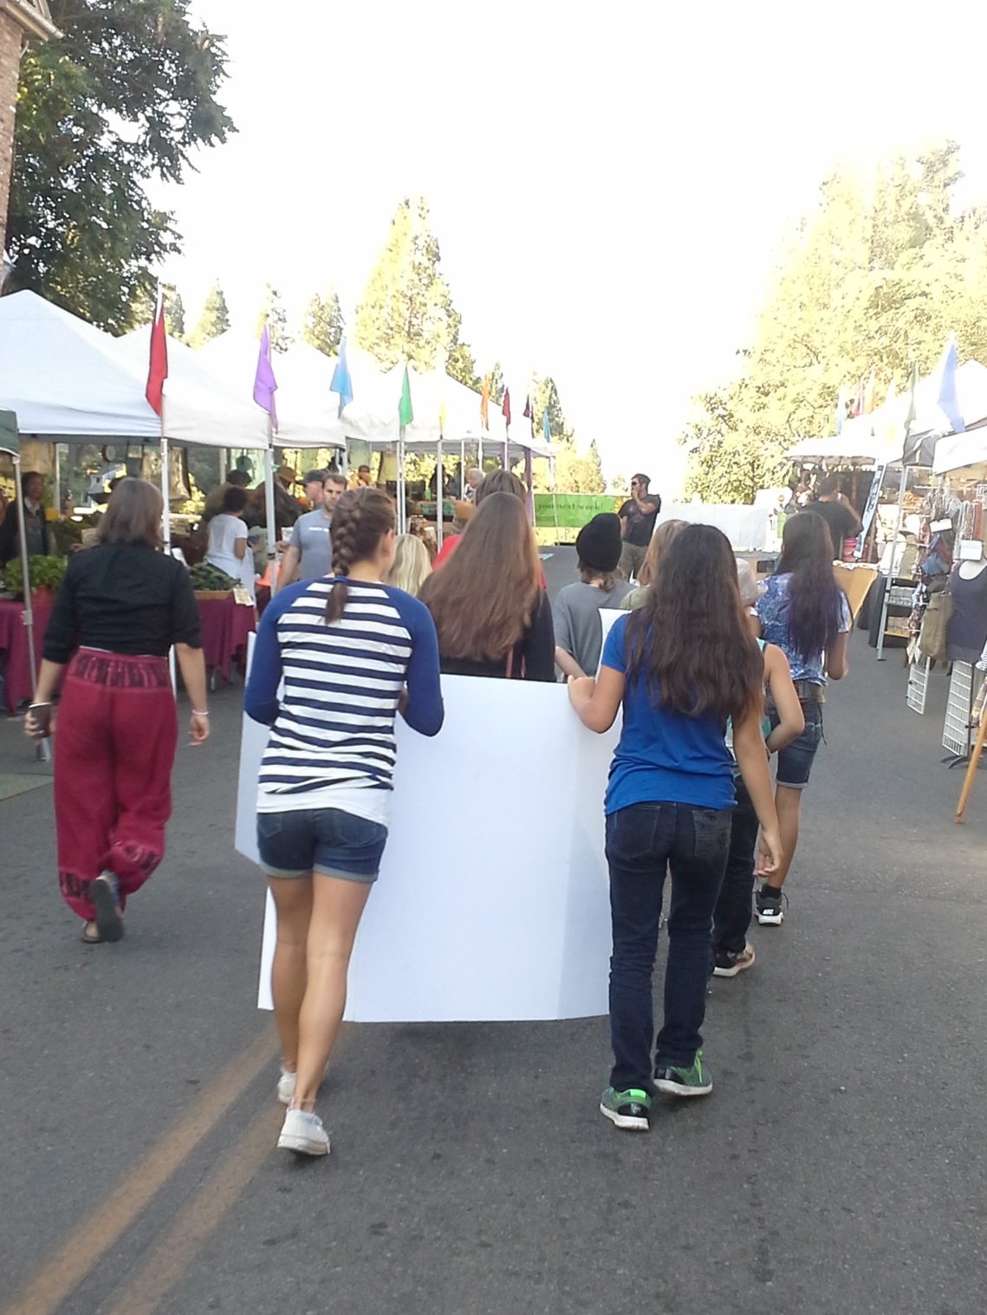
The change agents had the privilege of ringing the opening bell on market day and carrying their signs to share their messages with other vendors about various ways to protect the climate and its species.
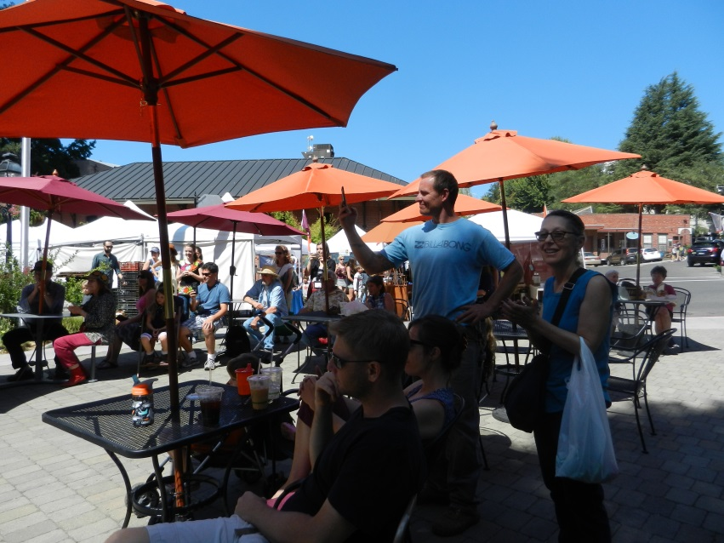

Some of the students gave speeches at the farmers’ market. Topics included: 1) explaining why nature is precious and asking adults to vote their conscience and thinking of their children in the future; 2) thanking Nevada County for going solar; 3) reading a letter the students wrote to their own African wisdom exchange partner about the relationship of deforestation and girls’ education.
The audience of viewers represented a small percentage of the community members the students reached. They also shared their knowledge by giving tours of the exhibit, speaking out at a picnic, and planning to send their message to the altar show (in honor of past environmental change agents) during Dia de los Muertos, to be held at the fairgrounds in October and early November, followed by displays at an NID site. They will also communicate with many more organizations and individuals through Youtube videos aimed at encouraging climate change research on candidates and issues before voting. Additionally, Union newspaper reporter Emily Lavin interviewed students about their perspectives and shared them with readers during the camp.

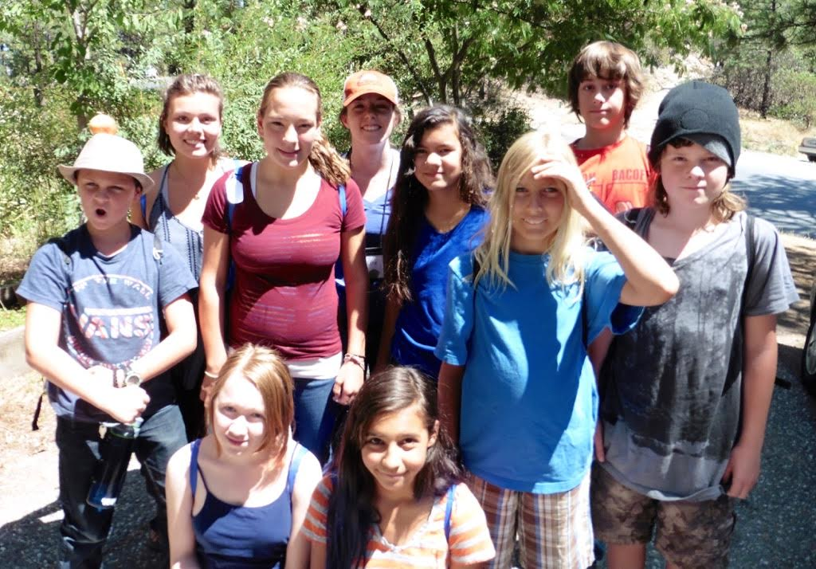
A Sugarloaf Peak hike offered views of bark-beetle infested areas. Here, the youth also practiced climate change games they would teach local children. (Photo by Don Baldwin)
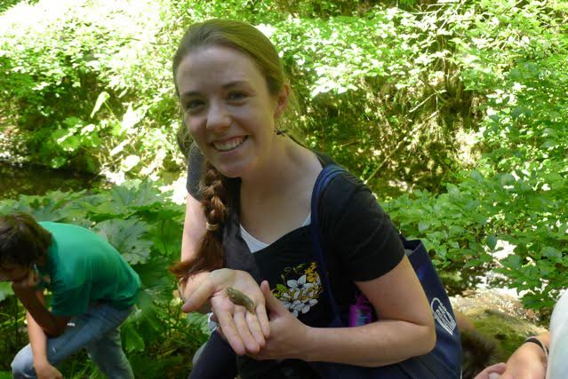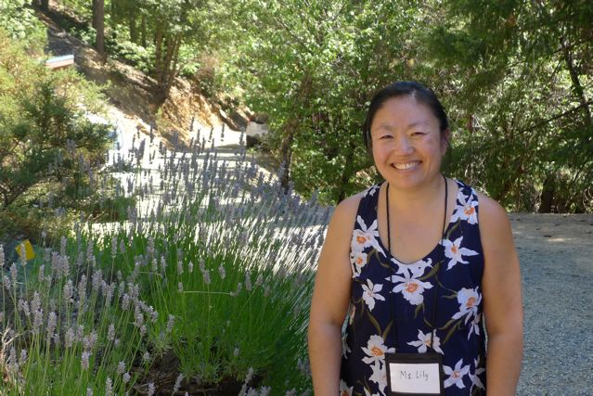
Committed teachers Katie Smith and Lily Ning traveled from Southern California to work at the camp. Local NC-CCC members and others volunteered as presenters, chefs, drivers, medics, photographers, and field trip hosts, including environmental guru/straw bale designer Nina Allen, left, with helper Rusty.
. 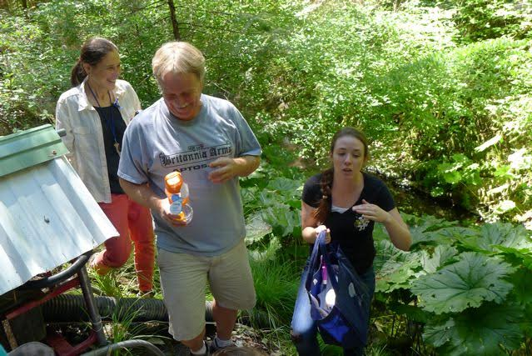

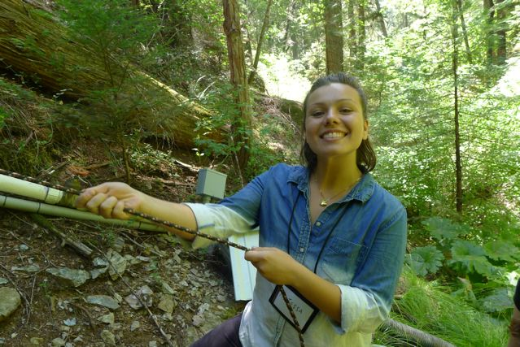
Counselor Tessa Fernandez pulled together with youth to hoist herself down a trail. After volunteering in Tanzania, she was able to teach batik as an art form, to help the group decorate hanging flags for the Tanzanian wisdom exchange partners. The flags depicted osprey, one of the species whose habitats we strive to protect in the Sierras.
The change agents who spoke on camera and in speeches explained why voters should think about maintaining a precious environment for their children, and they congratulated Nevada County for going solar. Their efforts to create change did not end there. By the last day, after their study of technologists, artists, thinkers and scientists helping victims of climate change, they experienced their own unique process to develop personal life goals. We spoke of the exponential impact of one person who saves or changes a life.
Malina and Lucy, below, took steps to plan careers as emergency responders for victims of climate change.Tanner wrote about advocating change through music. Sammy conceived a plan to start a wilderness center, where people with integrated specialties will come together to protect all living things. Together, the change agents pledged to continue on their path as Climate Change Agents.
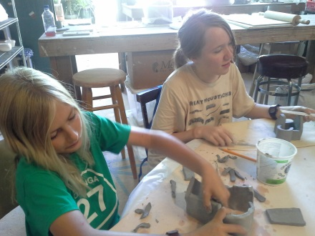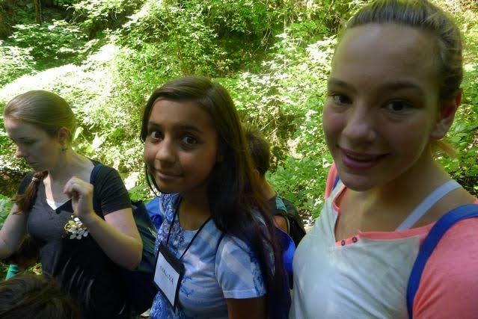

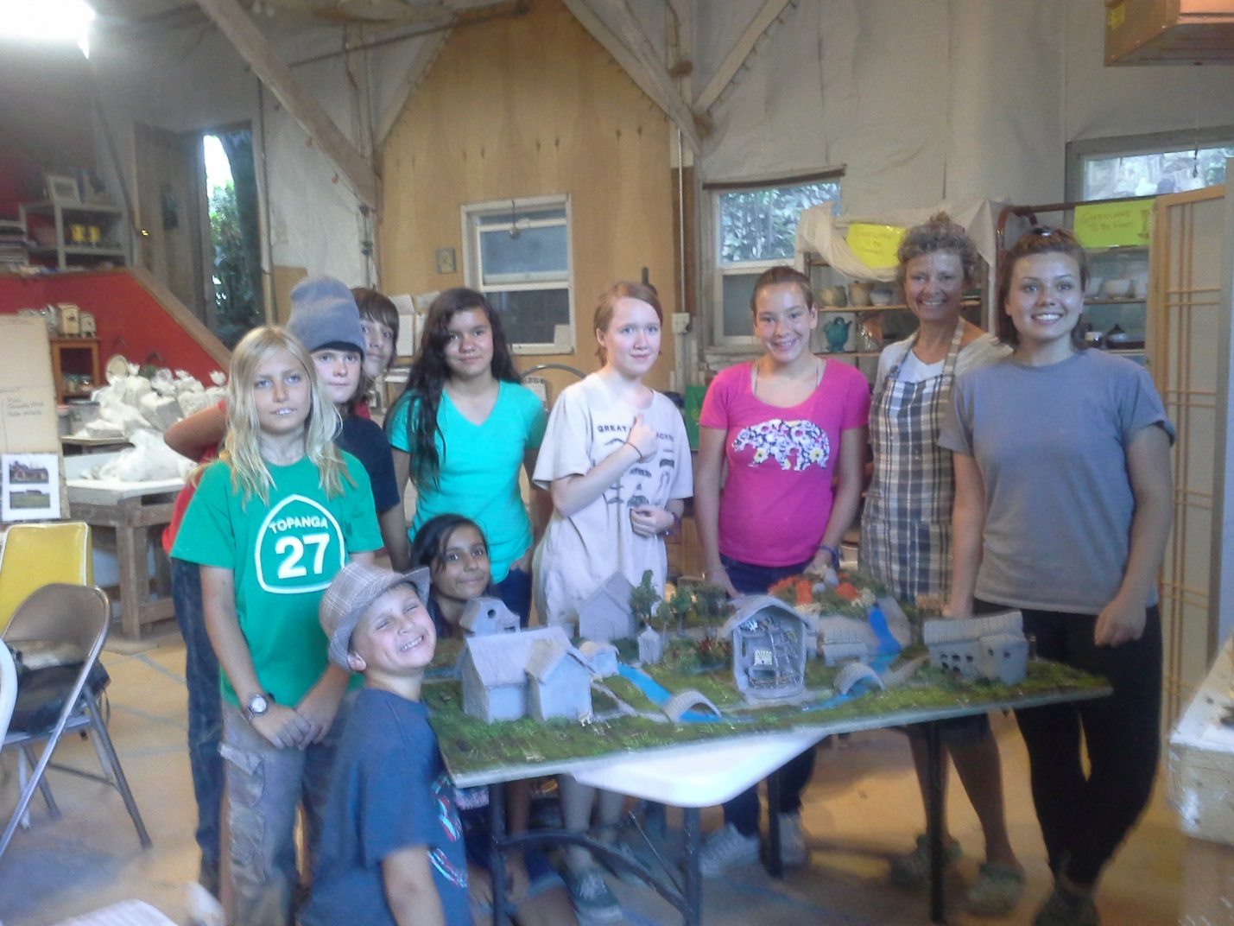
The Ethical Village design team posed in the in the studio with art mentor Rene Sprattling (second from right).
Thank you to this year’s wisdom keepers for collaborating with colleagues to share wisdom with the change agents on service-learning field trips:  Nina Allen  Rene Sprattling  Reed Hamilton  Alice Burkner  Rudy Darling  Chris Newsom  Neysa King  Sue Swenor | Thank you to the ten change agents who received scholarships and to those who were able to participate initiating a ripple effect to create future change:  Ruby Chow  Zach Damewood  Tanner Delgado  Samuel Eckl  Maisey Gill  Logan House  Kaiden Johnson  Malina Mitchell

Thank You to our Drivers, Meal Volunteers, Co-Sponsors and Funding Partners!
The Nevada County Climate Change Coalition sponsored the Climate Change Agents Camp with help from fiscal agent and education partner, Full-Circle Learning. Grants, scholarships and other financial assistance also came from the Rose Foundation, Audubon Society, Forest Issues Group, Nevada Irrigation District, Solar Cookers International and Nevada City Retreats.
Thank you to all who believe in the importance of engaging tomorrow’s change agents today, from the onsite team of Tessa, Teresa, Katie and Lily (pictured on page 15), and especially from the NC-CCC Education Group (Teresa Langness, Don Rivenes, Chris Newsom, Peggy Baldwin, Reed Hamilton, Carol Kuczora and Rondal Snodgrass).
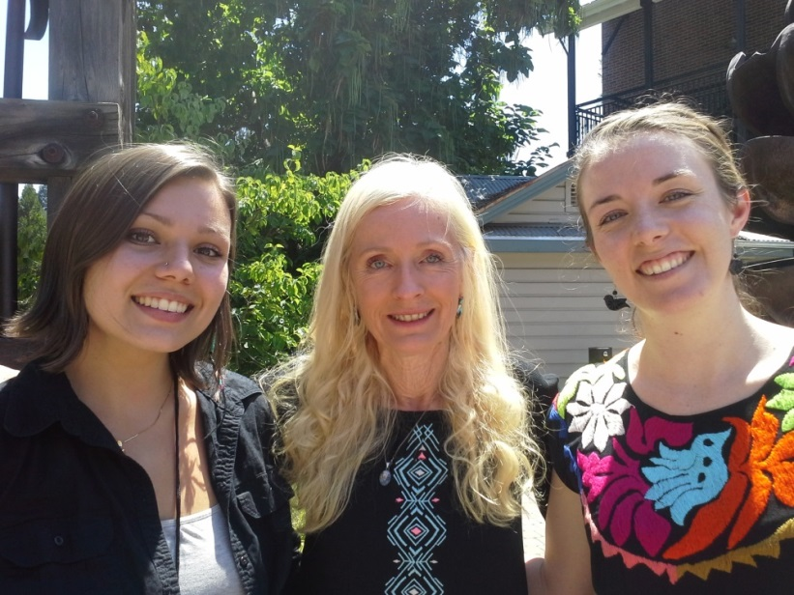
Nevada County Climate Change Coalition

