Concerns Turn into Convictions at
Climate Change Agents Camp 2022
(A Photo Essay)

Welcome to the official report of Climate Change Agents Camp 2022! Teams of change agents shared the camera, and this essay features the photos they left behind. (They kept many in the booth as souvenirs.)
More than exhibit 100 guests, as well as the learners in schools abroad, benefited from the work of this year’s Change Agents, who set out to “Turn Concerns into Convictions.”
Onsite, nine scholarship recipients and three leaders occupied the Papa Bear and Mama Bear cabins. Five wisdom-exchange scholarship recipients were denied visas or were absent for Covid-related reasons: two Latina, two Gambian and one Persian refugee living in the UK.
The Gambian Change Agents participated in absentia. Having attended Full-Circle Learning schools throughout their lives, they wanted to share what they would have brought to the camp relevant to its theme. A tropical storm made travel impossible for them during camp week, but by the end, they came together to shoot a video for our camp, featuring their original poetry recitations, staged in full costume in a Gambian forest, so they could share their voices from a distance.

The camp’s introductory activities this year helped youth collaborate to write a constitution based on group convictions. Change Agents added their own personal convictions to a centerpiece poster for the exhibit designed to encourage the public to reflect on the need to develop belief systems and commitments that inspire hope and action.
To prepare for the exercise, each group conceptualized a country with one of the three current priorities listed in the latest Drawdown updates:
1) Reduce Carbon Sources: bring emissions to zero (the Doers);
2) Support Sinks: uplift nature’s carbon cycle (the Dreamers); and
3) Improve Society: foster equality for all (the Doves).

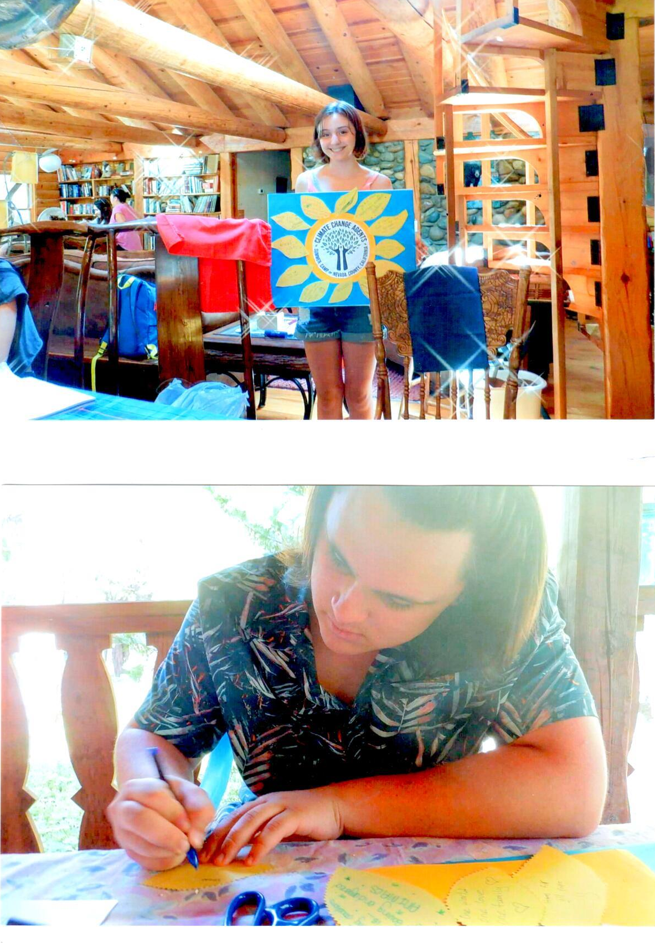

Activities pivoted around a solar-powered globe. Change Agents evaluated the influence of “acting on convictions” to generate hope for humanity and for the planet. Stories of role models and their impacts on interlocking systems supported the concept that a lifetime of small actions and attitudes can make a resounding difference.
The Doers then tried to form a hypothesis on ways to reduce the number of fuel-guzzling fighter planes and replace them with innovative solar-enhanced planes. The team spent hours building and testing prototypes of battery-operated planes, based on offsite advice and suggested materials from former Space-Ex engineer Rod Mobini. They named their three planes Hope, Conviction and Solar Dove.
Next, they studied the practicalities with solar specialist Rob Katzenstein (pictured discussing the findings with counselor Logan House). Rob showed how to calculate and compare solar power with other energy sources, to keep a plane aloft and lengthen its flight time, based on weight and passenger load. In search of a feasible option, the team wrote letters to Northrup-Grumman and to Boeing, asking their design teams for help with the effort. They hoped to encourage these experts to design planes that spare the air as well as the lives otherwise lost in wars.
Meanwhile, the Doves created a map showing the hot spots that could ultimately make agriculture untenable and influence migration patterns in equatorial regions. They identified the countries most likely to receive an increasing influx of climate refugees. They determined ways to welcome those refugees as members of the human family, who deserve to apply their agricultural skills to reduce hunger for all.

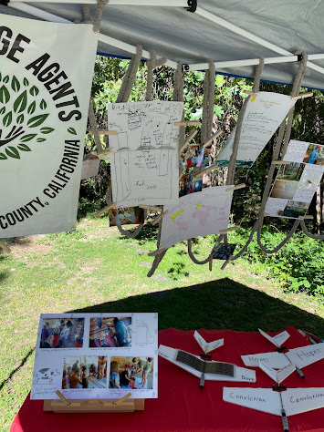

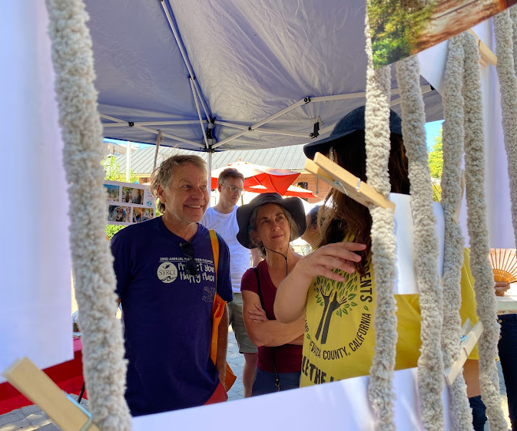

The Dreamers evaluated the interlocking belief systems, economic systems, and ecological systems in our own backyard. They researched the impact of climate change on food security, considering the bumble bee as a pollinating indicator species. Pesticides and shifting weather patterns have reduced bees and confused pollination cycles. One of the Dreamers, Jessica Rivenes, wrote an opinion piece for The Union newspaper, suggesting ways to protect the local bee population. Tanner Delgado scouted the property to submit an accompanying bee photograph. Shaela Applegate added supporting poetry for the exhibit and to send to the Gambian wisdom exchange partners, who had shared their hope and aspirations poetically. All gathered to make food covers from recycled cotton napkins, beeswax and pinene resin, a sticky fabric substitute for plastic wrap.
Next, two groups came together to make seedballs, a food security practice learned from one of the Gambian Full-Circle Learning schools, where students throw clay-soil-and-seed balls into bush, to promote the spontaneous growth of food for the public to eat. Our Change Agents included herbs and medicinal plants as well, throwing the balls near the compost pile, where their growth would benefit from its nutrients and from the moisture retention in the shady area.

Our counterparts in West Africa face increasing storms that bring about water-borne disease and contaminate local drinking water. Most live in homes without electricity or running water. Making a biodigester, we demonstrated how to use animal waste and food waste to generate natural gas for cooking. Travis Duckworth led the teams to make three biodigesters. The Doers demonstrated uses at the farmers market and described the process in videos for the wisdom exchange partners.
A trip to Johnny Appleking’s (Johnny Pomeroy’s) farm included explanations of economic systems among farmers. He also discussed fire resilience. The animal pond in the photo stands near the goats’ playground. They keep the grasses and “fire duff” under control. Johnny demonstrated the value of prescribed burns and the methods of ensuring safety when conducting them. At this point, Change Agents had already mastered terms associated with a dozen carbon-reducing practices, from biochar to biofuels to biomass to sequestration to silvo-pasture. They saw some of these practices in action, through a demonstration of a prescribed burn and a visit to the historic Vogt Ranch, where the Doers snapped shots of cows dining in style among the trees and pastureland in an idyllic silvo-pasture setting. The Doves and Dreamers went on to a former Nisenan village site to identify the wisdom we have inherited from indigenous land management practices and to imagine gifts from each person’s own heritage they would offer in return.
Next, the teams each had a shopping challenge. Doers brought home a dessert based on products with low transportation miles. Dreamers purchased vegetables, focusing on biodiversity and those least likely to result in food waste. Doves created a dish honoring cultural diversity. All prepared their dishes together for a well-earned dinner that night.
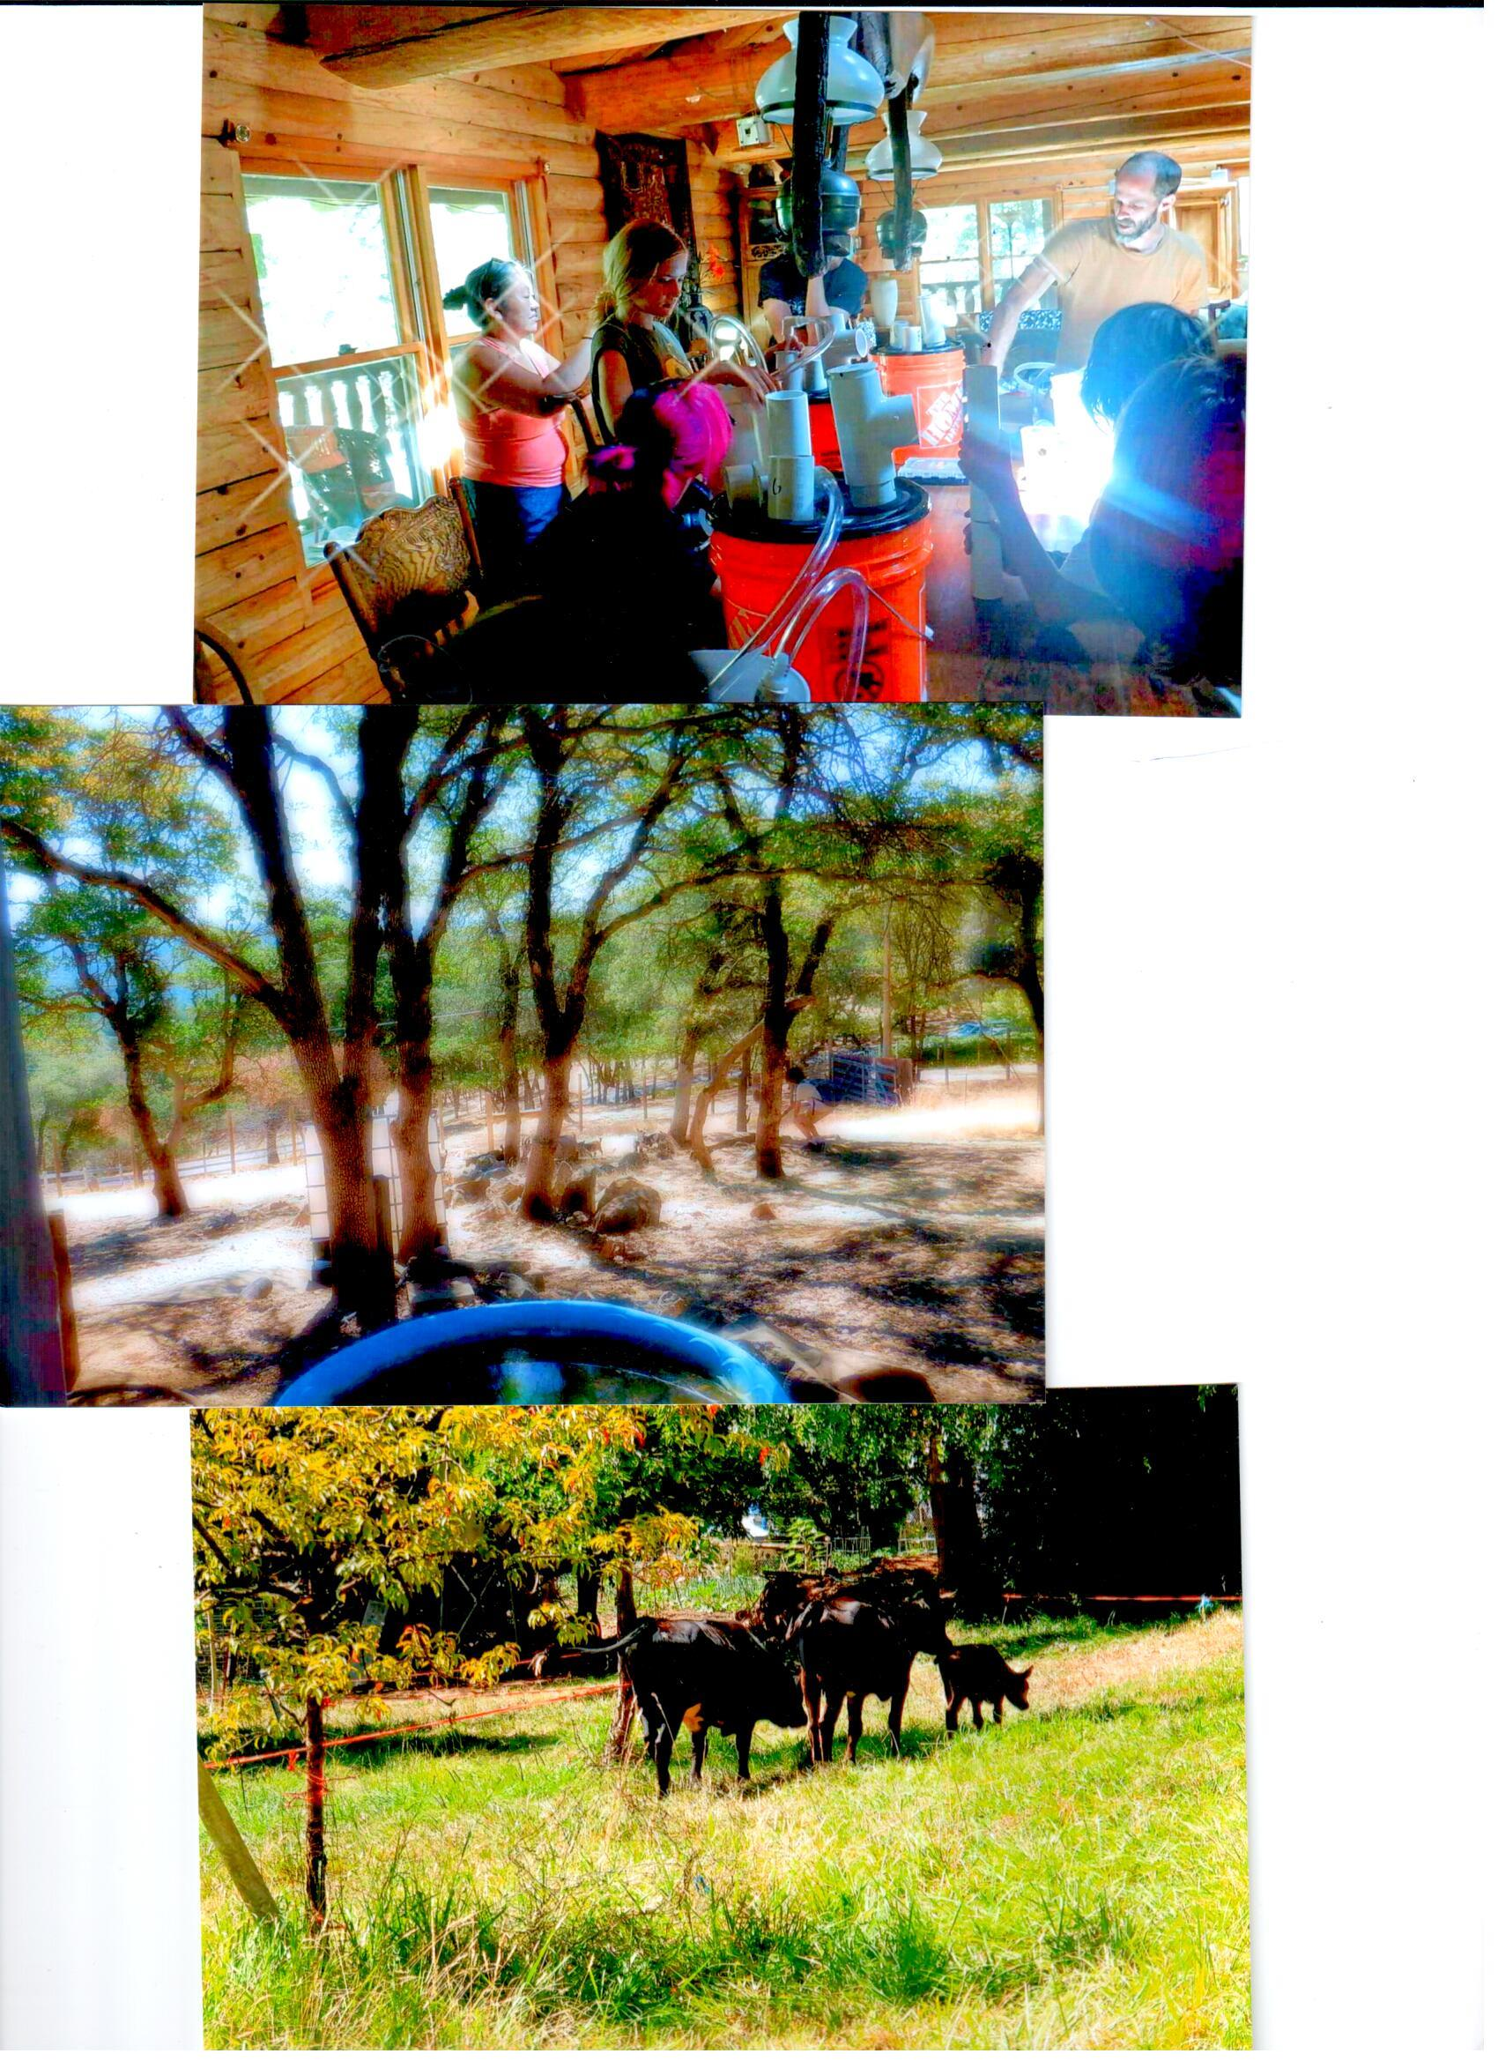

The next day, Hilary Applegate, author of Make Soil, Not War, led a field trip in her experimental garden, teaching the group how to make hot compost to improve the properties of the soil. The students offered their service by mixing the compost with water to irrigate the garden, differentiating the affected section from the rest of the plot.
At El Milagro Restaurant, Change Agents noted that after the Nisenan, other cultural and linguistic groups enriched the human diversity of California. They particularly noted the contributions of Mexican-Americans and Chinese-Americans. Phone books provided practice pages for conducting diversity counts. Each group looked for an assigned category, equating natural geographic features with cultures represented on a census, to understand the methods for a bird count, a county-wide homelessness count, a population census, and a biodiversity index in a natural preserve.
The group then went to the Adam Ryan Preserve and the Alan Theisen trail to count the diverse species and plant numbers in this land trust preserve. Each team covered equal acreage as they sorted indigenous and non-indigenous plants and counted flora and signs of fauna within the habitat. Star Carroll attended as a guide and native plant specialist.
The three teams combined their findings (species and individual items per acre) and wrote a cover letter, thanking long time land trust advocate Rondal Snodgrass and Sierra wildflower specialist and author Julie Carville for working to protect biodiversity. Their flora and fauna “report card” indicated a high level of biodiversity in the lower trail and marsh, based on number of species, number of individual plants, and animal signs per acre. The top of the hill sheltered mostly indigenous plants, although the thick canopy of oak and pine harbored a lower rate of plant diversity.
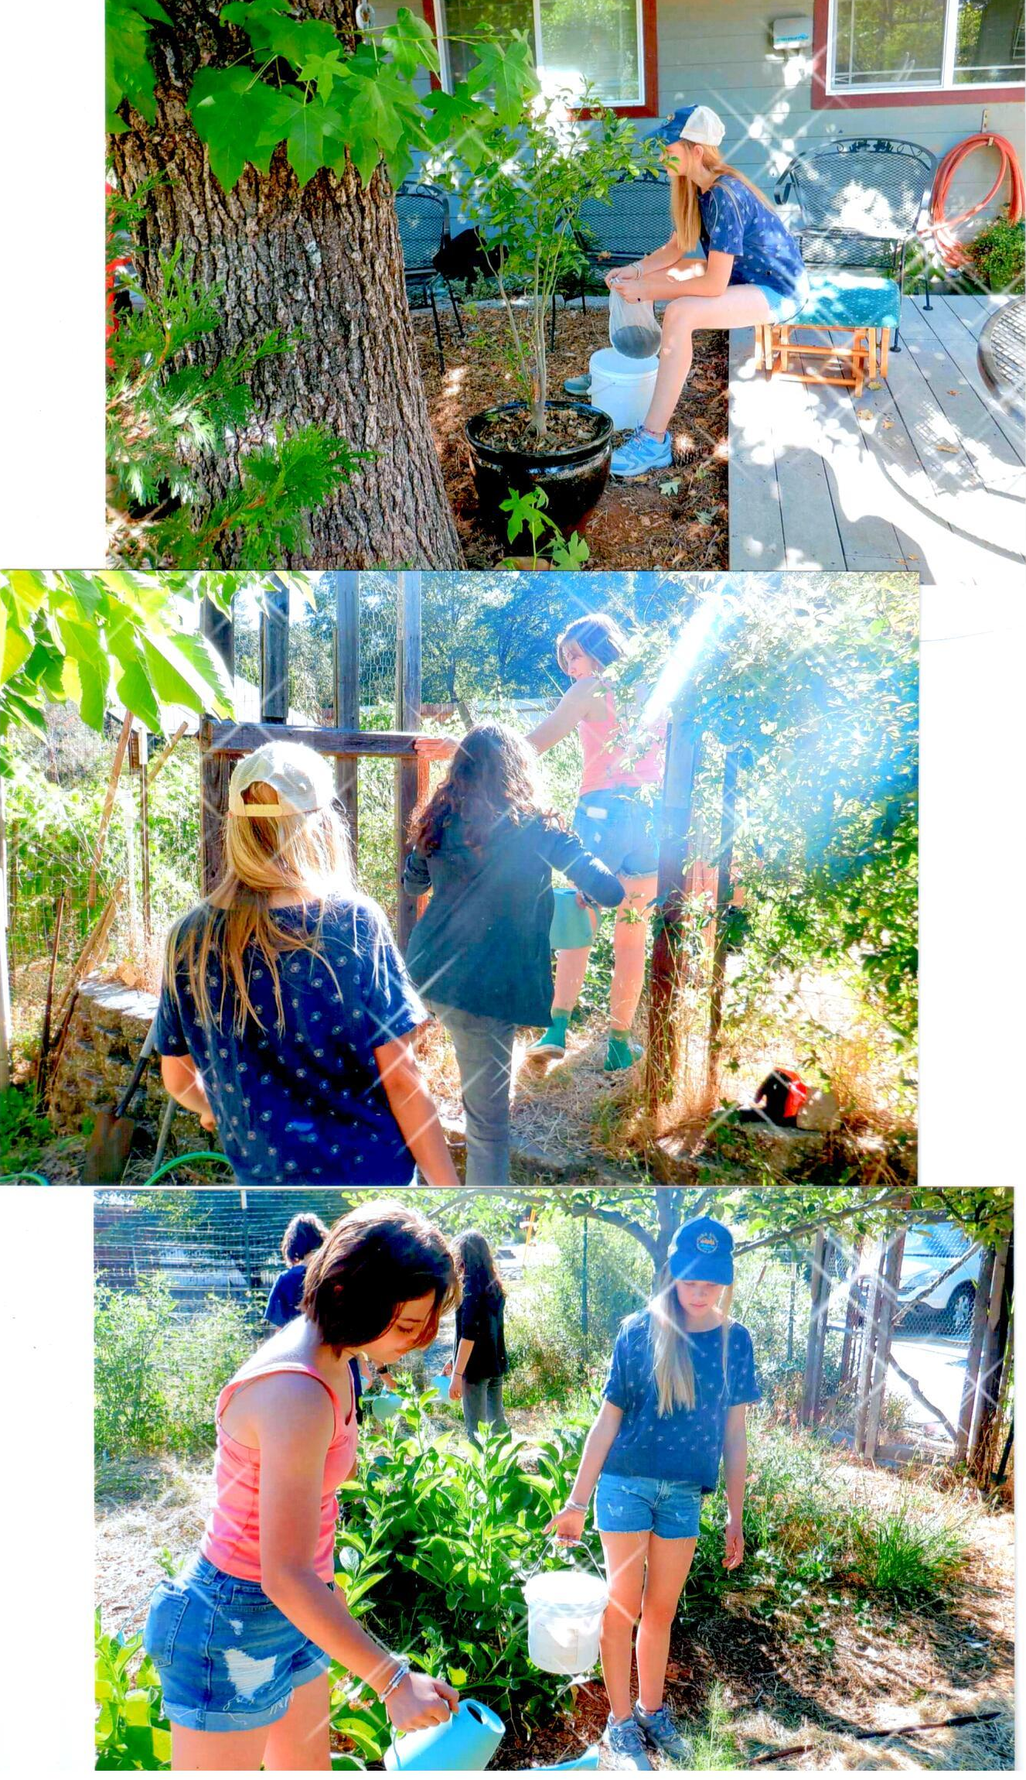

Extending the concept of “counts,” the Change Agents went together to honor Brad Pecimer for recycling and refurbishing donated R.V.s, to create homes for more than 100 homeless families. He, in turn, gave a tour of his well-insulated rammed earth home and explained the building process that had kept the home’s heating- and cooling-related costs and carbon emissions at almost zero.
Each evening, the students gathered under the madrone tree to discuss the deep questions of the day regarding their convictions. One night, Maggie McKaig and Luke Wilson led a singalong. Another night, we held the traditional owl presentation and, as always, scouted out two owls, thanks to Rudy Darling’s knowledgeable owling methods.
Lakshmi and Dava Greenberg choreographed a dance to the song “Whatcha Gonna Do?” A video went to the Gambian team, along with a message from each Change Agent and a video explanation of the projects in the booth. The partners responded with gratitude, having longed to be here in person.
Rene Sprattling and Susi Steinbarth led the art projects. The Change Agents made placemats from recycled newspaper, encouraging Brad Pecimer to decorate his recycled homes with them, and also offered them to other guest presenters, along with the beeswax food covers. The centerpiece of their booth symbolized the importance of working together in unity. Pairs from each diverse group plunged one hand into a mold for clay. When dry, they decorated the united hands to show their support for living systems. One sculpture was placed near a bench in an open space, as public art. The week ended with an ice cream social near the exhibit and performance stage where more than 100 people received the message taught by the Climate Change Agents 2022: You too can be a change agent!
