Senator Jeff Merkley
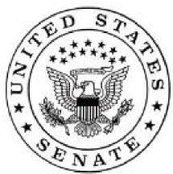

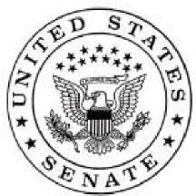
100 by ‘50 Act :
Transitioning America to 100% clean,
renewable energy for all by 2050

The 100 by ’50 Act lays out a roadmap for the United States to transition away from fossil fuels and towards 100% clean and renewable energy by 2050. With a combination of existing technology and future investment, the 100 by ’50 Act lays out the policies necessary to make this long-term vision for our energy economy a reality.
The bill includes seven key features to reach 100% by 2050:
- Greening the Grid— Phase-out fossil fuel electricity by 2050 and replace it with clean and renewable energy through a mandatory fossil fuel emissions phase-out and major investments in clean and renewable energy, storage, and grid infrastructure to ensure reliability and affordability.
- Electrifying the Energy Economy—Connect as much of our transportation and heating systems as possible to the clean electrical grid through a national zero emissions vehicle standard, major investments in zero emission vehicles and zero emission heating systems.
- Clean and Renewable Energy for All—Ensure that low-income families and disadvantaged communities share in the benefits of a transition to 100 by ’50, through grants to make clean energy, energy efficiency, and public transportation affordable and accessible, and to provide job training for the clean energy sector.
- Just Transition for Workers—Provide resources that will help workers, and their communities, in today’s fossil fuel-based economy to find good jobs in growth industries of the future, and get fair benefits between jobs or at retirement.
- Ending New Fossil Fuel Investments—End approvals for major fossil fuel projects like the Keystone XL pipeline and Dakota Access Pipeline, and discontinue fossil fuel subsidies.
- Ensuring American Competitiveness—Create a level playing field for energy-intensive US products by imposing a carbon duty for carbon-intensive products imported from other countries.
- Mobilizing American Resources—Finance a rapid and smooth transition to 100 by ’50 by auctioning Climate Bonds and investing the funds in the new programs created by the 100 by ’50 Act. Funds will go toward the range of new investments in the bill, including a new climate justice resiliency fund to support disadvantaged communities in managing the impacts of climate change, and provide planning grants to organizations, communities, tribes and states to develop their own 100% plans and jump-start the transition.

